Microsoft Windows Protocols Test Team

Abstract
Training in File Server-SMB2 Test Suite Technology
Author
Abiodun Aremu | Microsoft Software Engineer II
File Server-SMB2 Test Suite
Version 2.4
Tutorial
September 2023
Table of Contents
1.0 Introduction 3
1.1 Test Suite Training Audience 3
1.2 Goals of the Test Suite Training 3
1.3 Training Session Details 3
2.0 Glossary Definitions 4
3.0 Concepts 6
3.1 What You Will Learn 6
3.2 Installing a Test Suite 7
3.3 Protocol Communications 9
3.4 Test Environment Architecture 11
4.0 Configuring the Test Suite 12
4.1 Configure the Test Environment with the PTM Service 14
4.2 Configure the Test Environment by Loading a Profile 24
5.0 Running the Test Suite Test Cases 26
5.1 Running the Test Cases 29
5.2 Create File Demo 33
5.3 Saving a Profile 33
5.4 Executing Test Cases From the Command Line 38
6.0 Analyzing the Test Results Data 40
6.1 Test Results Output and Status Indicators 40
6.2 Status Indicator Meanings 43
6.3 Common Failures 43
7.0 More Information 44
7.1 Resources 44

Table of Figures
Figure 1. PTM Service landing page 8
Figure 2. Install Test Suite dialog 8
Figure 3. SMB2 protocol messages example : Setting up an SMB2 share connection 10
Figure 4. File Server-SMB2 Test Suite : Network test environment 11
Figure 5. Test Environment : Test Cases communication path 12
Figure 6. PTMService landing page 13
Figure 7. PTM Service : Tasks list 13
Figure 8. PTM Service : Select Test Suite page 15
Figure 9. PTM Service: Test Suite Introduction page 16
Figure 10. PTM Service: Domain and Workgroup environments 17
Figure 11. PTM Service : Select Configuration page 17
Figure 12. PTM Service : Configure Method page 18
Figure 13. PTM : SUT detection input data 19
Figure 14. PTM Service : Reviewing Auto Detection results 20
Figure 15. PTM Service : Filtering test cases 21
Figure 16. PTM Service : Configure Test Cases page : Common Properties 23
Figure 17. PTM Service: Configuring an SUT control adapter 24
Figure 18. PTM Service : Loading an existing Profile 25
Figure 19. PTM Service: Validating Profile test cases prior to execution 26
Figure 20. PTM Service : Selecting Test Cases to execute 27
Figure 21. PTM Service : High-level Status Results Categories 28
Figure 22. PTMService : Import/Export Playlist feature 29
Figure 23. PTM Service : Executing selected Test Cases 31
Figure 24. PTM Service: Test execution History view 31
Figure 25. PTM Service : View Results page 32
Figure 26. Create file demo 33
Figure 27. PTM Service : Saving a Test Cases Profile 34

1.0 Introduction
This tutorial provides step-by-step instructions for connecting to and configuring the File Server-SMB2 Test Suite (FSSTS) via the Protocol Test Manager Web Service (PTM Service), in preparation for executing predefined Test Cases that exercise various functions of SMB protocol dialects in file sharing scenarios. Following test execution, you will perform some basic analysis of test results. You will be provided with the test environment assets that facilitate the configuration and execution of tests.
The management of test environment configuration, Test Case execution, and test results analysis are all achieved with the use of the PTM Service. This tutorial will show you how to use the PTM Service to accomplish these tasks. The PTM Service tool and the File Server-SMB2 Test Suite are installed on a Driver computer where you will conduct the testing. You can access the PTM Service from a web browser on your device or on the Driver computer. You will have access to the Driver computer via the Remote Desktop Protocol (RDP).

1.1 Test Suite Training Audience
The primary audience for the FSSTS training is software developers who have little or no experience with running protocol Test Suites. Other audiences can include support personnel, IT professionals, and others who may be interested in learning about protocol Test Suites.

1.2 Goals of the Test Suite Training
The primary goals of this training session are as follows:
- Learn the basics concepts of simple protocol communications.
- Obtain a preliminary understanding of the File Server-SMB2 Test Suite (FSSTS) and PTM Service test environment.
- Learn how to use the PTM Service to manage the configuration, filtering, test execution, and test results analysis features of the FSSTS.

1.3 Training Session Details
A typical organization of this lab session and the time allocated for the session tasks are indicated in the following table.

Table 1. Training session organization
Session Task | Allocation (minutes)
Review glossary terms and conceptual material | 10
Configure Test Suite and run Test Cases | 20
Analyze test results and ask questions | 15
Total time | 45

2.0 Glossary Definitions
The following list defines the important terms that are frequently used in this tutorial.

Authentication token: A security device that enables a user or application to gain authorized access to secured resources, such as a network service.

Driver computer: A computer on which the FSSTS is installed and configured. After installation, you can run the preconfigured test cases that are part of FSSTS. In the test environment, this computer typically runs a Windows client operating system.

File Server-SMB2 Test Suite (FSSTS): A set of preconfigured, software-coded Test Cases that exercise features of the SMB2 protocol and other protocols that are associated with file services. FSSTS contains the framework for configuring the test environment, executing tests of File Server features, and facilities for analyzing test results.

Implementation: A coded representation of the functions of a protocol that contains the messages and formats required to establish communications between computers across a network, for the purpose of servicing application functions via sending client requests and replying with server responses.

Isolated network: For testing protocols with the FSSTS, this a network that is disconnected from the internet, uses an isolated hub or switch, and is not part of a production network of any kind.

Message : A packet of data that sends instructions or other information in the form of a request or a response, from one computer to another.

Wireshark: A network tracing and analysis tool that enables you to capture, display, and analyze protocol messaging traffic. It also provides the capability to retrieve, aggregate, and analyze data from one or more saved traces.
Optionally can be used in this tutorial to analyze event trace log (ETL) data, as generated during Test Case execution.

Profile: A file generated by the PTM that represents a configuration of Test Cases that you optionally create and store in a directory location following Test Case execution. A Profile acts as a template that enables the repetitive reapplication of an identical set of Test Cases against a common system under test (SUT) environment.

Protocol: A set of rules or procedures that define how data is transmitted between computers. To achieve a successful interchange of information, a protocol establishes the structure of the information, the transmission method, and how the sending and receiving nodes process the information. The functions of a protocol are typically expressed as a set of message packets, which in turn reflect the protocol’s rules.

Protocol Test Manager Web Service (PTM Service): Consists of a built-in user interface that provides all of the functions and facilities for performing the tasks associated with using the Test Suite, which include the following:
- Detecting the SUT configuration and capabilities
- Creating a default set of Test Cases, based on the assessed SUT environment
- Optionally reconfiguring the default Test Case selections
- Running the Test Cases
- Analyzing the test results

See Configuring the Test Suite for further information.

Provisioning: A term that is used to describe the process of setting up computers and specific resources for a predetermined purpose. For example, a company might have need of an SMTP mail server or an Internet Information Services (IIS) web server for their business. Companies such as Microsoft and others will set up, customize, and maintain those systems in the Azure hosting space for the customer in an agreed-upon contract. Providing such resources is commonly known as provisioning.
Note that the Driver computer and SUT computer are virtual machines (VMs) that may be provisioned by Azure services or by other resources, for the purposes of this lab session.

Remote Desktop Protocol (RDP): The protocol that facilitates the well-known Remote Desktop Connection application that enables users to connect from their local computer to a specified remote computer, so that users may access the resources of such a computer.

Server Message Block (SMB2) protocol: The SMB2 protocol is typically used by clients to request file and print services from a network file server. The protocol enables you to establish a server connection, an authentication context for the connection, and to thereafter request access to files, shares, and printers.
The SMB2 protocol is the mechanism that enables you to open, read, modify, and close files on a target server; to query and apply attributes to files or volumes on a target server; to moderate the shares and users; and to simultaneously open files. It also supports the creation of symbolic links, a function which, for example, enables you to create a link to a file or directory from another file in a different directory location.

SMB2 client: Typically a computer that uses a particular SMB2 dialect or later to make SMB requests to an SMB file server to obtain access to file system resources for reading and writing data. The SMB2 client sends and receives data to/from the SMB2 server via message packets of the SMB protocol. Note In the context of this training , the SMB2 client is the Driver computer and the SMB2 server is the SUT computer.

SMB2 server: A computer that receives and services requests from an SMB2 client via the message packets of the SMB2 protocol.

SMB2 dialect: The SMB protocol comes in several versions that are known as dialects, for example, SMB v2.0.2, 2.1, 3.0, 3.0.2, 3.1.1, and so on.

System under test (SUT) computer: A computer that hosts the system against which the pre-defined Test Cases are to be run by the FSSTS that is installed on the Driver computer. Typically, the FSSTS tests an implementation of the SMB2 protocol, which can be either a proprietary, developed SMB2 implementation or the SMB2 service that runs on the SUT computer by default.
For purposes of this training and the preconfigured setup that is used, the Microsoft SMB2 service on the SUT computer serves as the underlying implementation being tested. In the test environment for this lab training, this computer typically runs a Microsoft server operating system.

Test Case: An executable application hosted by the Test Suite that is designed to test unique aspects of File Server features that use the SMB2 protocol within the context of an SMB2 client and SMB2 server communication session.
Note: An FSSTS installation can contain thousands of Test Cases.

Virtual machine (VM): Typically an emulation of a computer system that has a computer architecture and provides the functionality of a physical computer, but its implementation is software based and has no physical component, other than a physical computer on which the VM is hosted.

3.0 Concepts
This section briefly describes the major concepts with which you will become familiar by taking the FSSTS Lab Session course via this tutorial . The material begins with describing how to install a Test Suite. Next, you will learn some basic concepts of protocol communication and you will also learn about the test environment with which you will be working, as indicated in section 3.1 What You Will Learn, directly ahead. This section also points you to other sections of this tutorial that show you how to use the PTM Service to configure the Test Suite, select and run the Test Cases, and analyze the test results.

Note
If you have not already done so, you should read the preceding Glossary definitions to obtain a brief overview of pervasive concepts in this tutorial.

3.1 What You Will Learn
This section provides an overview of the scope of this tutorial , in terms of the specific things that you will be learning, as follows.
Installing a Test Suite provides a simple and quick process to install a chosen Test Suite.
Protocol Communications introduces the basics of protocol communications by giving a hypothetical example of the initial exchange of SMB2 protocol messages that are used to set up an SMB2 session.
Test Environment Architecture shows a basic network diagram that is similar to the test environment in which you will be working, provides a description of its components, and shows a graphic representation of the Test Cases communication path between the Driver computer and SUT computer.
Configuring the Test Suite shows you how to use the PTM Service, the primary user interface that you will utilize to manage test environment configuration on the Driver computer.
Running the Test Suite Test Cases shows you how to use the PTM Service to manage execution of File Server-SMB2 Test Suite (FSSTS) Test Cases on the SUT computer, initiated from the Driver computer.
Analyzing the Test Results Data shows you how to use the PTM Service to manage analysis of the test results.

Note
When you have completed the procedures in the latter three sections listed above, you will be finished with this tutorial .

3.2 Installing a Test Suite
The File Server-SMB2 Test Suite with the PTM Service should be installed on the Driver computer for use with this tutorial . However, for users who need to work with a different Test Suite, an option is available for installing other Test Suites such as:
- FileServer
- RDPClient
- SMBD
- MS-WSP

Such users are likely to be those who want to test an implementation of another protocol, for which a different Test Suite is required. In some cases, it could be a user who needs to reinstall the File Server-SMB2 Test Suite. The latest version of the Windows Protocol Test Suites is v4.23.9.0, released August 29, 2023, and is located here.

Important
You can install multiple Test Suites on the Driver computer. However , you can run only one Test Suite at a time.

If you need to install a Test Suite, perform the following procedure.
To install a Test Suite, including its corresponding PTM Service
- On the PTM Service landing page, as shown in the figure that follows (figure 1), select the linked Management tab to display the Test Suite tasks that you can manage, which includes the following:
- Rerun, Update, or Remove one or more Test Suites.
- Install a Test Suite.
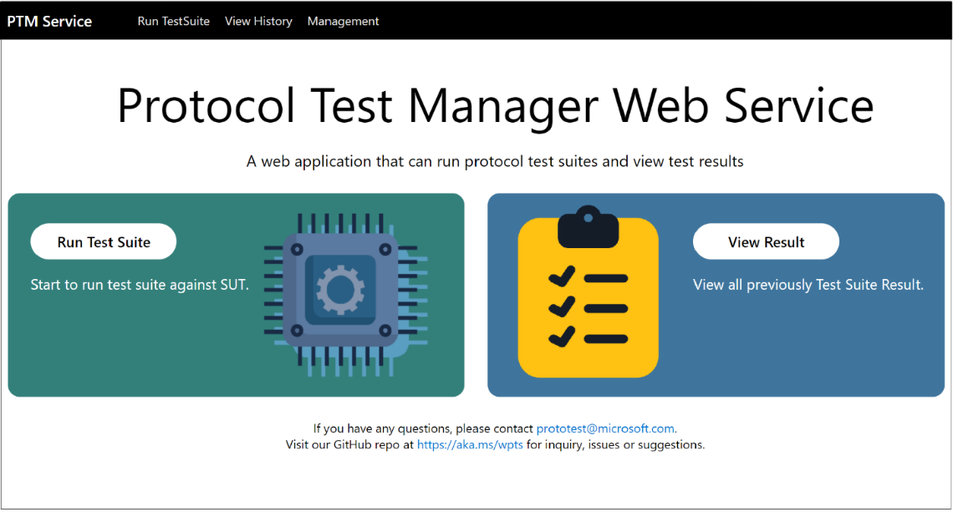
Figure 1. PTM Service landing page
- From the linked Management tab of the PTM Service landing page, select the Install Test Suite button to display the Install Test Suite dialog, as shown in the following figure.

Figure 2. Install Test Suite dialog
- In the Install Test Suite dialog, type a name for the Test Suite in the Test Suite Name textbox. Note that this is a user-specified value, to be named at your discretion.
- Select the folder icon in the Package field to navigate to the appropriate File Server-SMB2 Test Suite .zip file.
If you previously downloaded a particular Test Suite .zip file to a specified folder location, navigate to that location and select the Test Suite .zip file you want. Otherwise, locate the Test Suite .zip file on GitHub at this location.
- Type a description of the Test Suite in the Description text box at your discretion.
- To begin the installation, select the Install button in the Install Test Suite dialog.
Follow all instructions as the installation proceeds and monitor any installation errors that may occur.
- When the installation completes, select the Close button in the Install Test Suite dialog and then select the linked Run Test Suite tab on the PTM Service landing page.

To begin configuring the Test environment, see section 4.0, Configuring the Test Suite.

3.3 Protocol Communications
This section provides an example of protocol communications between an SMB2 client and an SMB2 server. It shows how several types of messages of the Server Message Block (SMB2) protocol are used to set up a session between an SMB2 client and an SMB2 server, in order to provide the client with access to a share on the server. The message exchanges basically consist of initial client/server negotiations, the client authentication process, and a connection request for share access.
A visual representation of the communication process in the following figure (figure 3) is accompanied by explanatory steps. The sequence of messages shown in the figure are high-level representations of the types of requests and responses that are typical of setting up an SMB2 session and connecting to a server share.
The goal of this section is to provide readers with a basic sense of how the File Server-SMB2 Test Suite on the Driver computer (client) communicates with the SUT computer (server). For example, in the Test Suite, a Test Case could invoke an SMB2 method and obtain confirmation as to whether encrypted access to a server share was successful or not; another test case might verify if a symbolic link within a share is working properly. These features are preconfigured on the SUT computer, against which real Test Cases are run from the Test Suite on the Driver computer.

Figure 3. SMB2 protocol messages example: Setting up an SMB2 share connection

- The SMB2 client sends a NegotiateRequest to the SMB server to establish the SMB protocol version or dialect in use by the client (SMB2, SMB3, and so on).
- The SMB2 server acknowledges the client’s SMB dialect and sends an SMB2 NegotiateResponse message back to the SMB2 client.
- The SMB2 client queries a security service for an Authentication token and sends a SetupRequest1 message to the SMB2 server.
- The SMB2 server responds with a SetupResponse1 message containing the authentication token and requests further processing from the SMB2 client.
- The SMB2 client performs processing on the authentication token and passes it, along with a SessionId, in a SetupRequest2 message to the SMB2 server.
- The SMB2 server processes the authentication token and sends a SetupResponse2 message back to the SMB2 client with a success status code.
- The SMB2 client completes the authentication process and sends a ConnectRequest message to the SMB2 server containing a SessionId and the name of the share to connect to.
- The SMB2 server enables the connection and sends a ConnectResponse message containing a success status code and other session information to the SMB2 client.

To summarize, when the File Server-SMB2 Test Suite performs tests, it begins by sending requests from the Driver computer and receiving responses from the SUT computer, in a manner that is similar to the message sequences shown in Figure 3. After a session is successfully set up, the Test Suite runs a host of preconfigured Test Cases that utilize important features and functions of the SMB2 protocol and other protocols to assess the system under test.
The Test Environment in which this occurs is described in the sections that follow.

3.4 Test Environment Architecture
The Test Environment consists of an isolated network with a Driver computer (client) and an SUT computer (server) hosted as Azure VMs in a Domain environment. Users will access the PTM Service on the Driver computer by entering the IP address of the Driver computer in a web browser. The basic network configuration is shown in the following figure.
Figure 4. File Server-SMB2 Test Suite : Network test environment
The components of the File Server-SMB2 Test Suite network Test Environment are described in the following list:
- User Workstation: A remote user laptop, Surface, or a lab computer from which you will connect to the Driver computer (a virtual machine) in a Domain environment via a specified URL, where you will configure the File Server-SMB2 Test Suite as described in section 4.0 Configuring the Test Suite for the system to be tested.
- Remote Desktop Protocol (RDP): A common protocol that you can use to connect with the Driver computer to access local features on the Driver, for example, the file system. It also enables users to execute .cmd files that are local to the Driver computer.
- Lab Server: — An optional test lab server, depending on the specific lab environment in which you will connect to the internet to access the Driver and SUT computers.
- Gateway Server: An optional server, depending on the lab environment, that will host the VMs configured in a Domain environment. It is setup by the Microsoft Test or Support teams, who will provision the VM computers and other resources that you will be using in the Test Environment.
- Driver computer: A VM that hosts the File Server-SMB2 Test Suite and PTM Service that you will use to configure and run Test Cases against the SUT configuration.
- SUT computer: A VM computer that is pre-configured with the required file shares and other features to be tested by the Test Cases of the Test Suite.

Important
In this Test Environment, you will not be testing a proprietary SMB2 implementation on the SUT computer. Rather, the Microsoft SMB2 service that normally runs on that computer will respond to the test messages generated by the Test Cases of the File Server-SMB2 Test Suite, which reside on the Driver computer, as shown in the following figure.
Figure 5. Test Environment: Test Cases communication path

4.0 Configuring the Test Suite
This section briefly describes how to configure the Test Suite Test Cases on the Driver computer with the use of the PTM Service, which is shown in the following figure (figure 6). You can connect to the PTM Service on the Driver computer by entering the Driver computer IP address in a web browser. The IP address and any other credentials should be communicated to partners on a designated Teams Channel before the event.

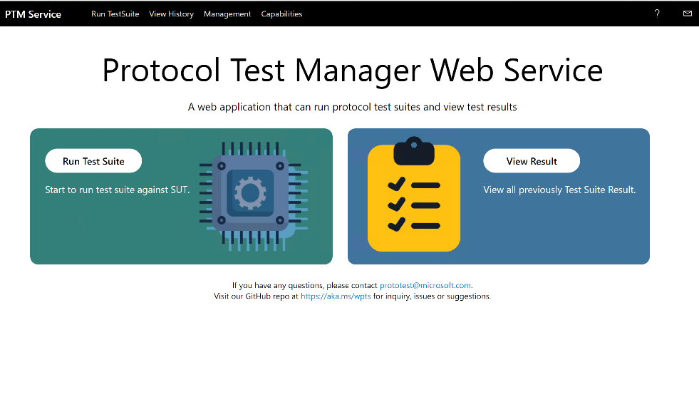
Figure 6. PTMService landing page
A list of tasks display when you start the PTM Service from the landing page by selecting the Run Test Suite button shown in the previous figure (figure 6). The tasks are shown in the following figure and are described thereafter.

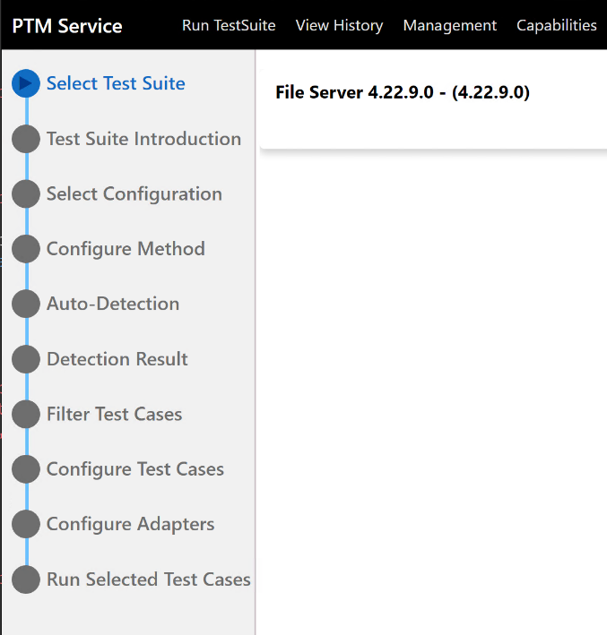
Figure 7. PTM Service : Tasks list
These tasks are briefly described as follows:

- Select Test Suite. Select the FileServer-SMB2 Test Suite from which to run your Test Cases.
- Test Suite Introduction. Review the file sharing protocols of the FileServer-SMB2 Test Suite, the implementations of which this Test Suite is designed to test. This introduction can help familiarize you with deployment configurations.
- Select Configuration. Specify the test case mode, either by running the existing set of Test Cases or configuring a new set of Test Cases.
- Configure Method. Select one of the following options:
- Run Auto-Detection. Automatically detects/assesses the SUT environment and obtains a default configuration of Test Cases based on such assessment.
- Do Manual Configuration. Manually configure the Test Suite and select Test Cases.
- Load Profile. Uses a saved configuration of Test Cases and corresponding test environment, known as a Profile, to enable comparisons with other target test results.
For example, running a baseline set of Test Cases against a modified environment or running a modified implementation against a baseline environment.
- Auto-Detection. Specify input information for locating the system under test (SUT) computer and run a detection routine to confirm SUT characteristics, capabilities, and environment compatibility for testing.
- Detection Result. Verify PTM Service detection, inspection, and validation of the SUT environment for test readiness. Also enables you to validate user input information such as Target Share, User Name, Password, and so on.
- Filter Test Case/s. Modify the default output of the Auto-Detection process, by selecting/unselecting (filtering) Test Cases to create a unique test configuration. Per an Instructor of this tutorial , you might configure specific tests to create focus on specific sets of test results.
- Configure Test Case/s. Review or optionally reconfigure Test Case properties to refine or make corrections to property values.
- Configure Adapter. Select the type of control adapters to use and specify script locations when required:
- SUT Protocol control adapter: Use this adapter for the FSSTS with the Managed setting.
- Common SUT control adapter: Not applicable to FSSTS.
- Fail SUT control adapter : Not applicable to FSSTS.
- Run Selected Test Case/s. Run all cases or run only selected Test Cases at execution time from this page.

You will complete the items cited in the above list in section 4.1 Configure the Test Environment with the PTM Service that follows. Thereafter, you will run the Test Cases and then perform simple analysis on test results to obtain a basic understanding of the analysis features.

Optional Configuration Scenario
If you have already run through an execution of Test Cases and saved a Profile per the procedure in section 5.2 Saving a Profile, you can proceed to section 4.2 Configure the Test Environment by Loading a Profile to set the Test Case configuration with a Profile prior to execution, instead of performing the configuration in section 4.1 that follows. For the section 4.2 procedure, note that you will need to have the PTM Service open to the Configure Method page to load an existing Profile.

4.1 Configure the Test Environment with the PTM Service
The PTM Service contains all the features and functions you will need from this point forward to configure, run, and analyze Test Cases.
To access the PTM Service and begin configuration tasks
- If you have not done so, connect with the PTM Service on the Driver computer by entering the Driver computer IP address in a web browser. This IP address and any other required credentials should have been referred to you on a designated Teams Channel prior to the event.
The PTM Service should automatically display its landing page when you connect, as shown earlier in section 4, Configuring the Test Suite.
- To begin the configuration process, select the Run Test Suite button on the PTM Service landing page to open the Select Test Suite tab, as shown immediately below.
- On the Select Test Suite page of the PTM Service, select the Select button to the right of the FileServer (4.22.9.0) label to get the latest version of the File Server-SMB2 Test Suite, as shown in the following figure (figure 8).
The Test Suite Introduction page should display, as shown ahead of the following figure:
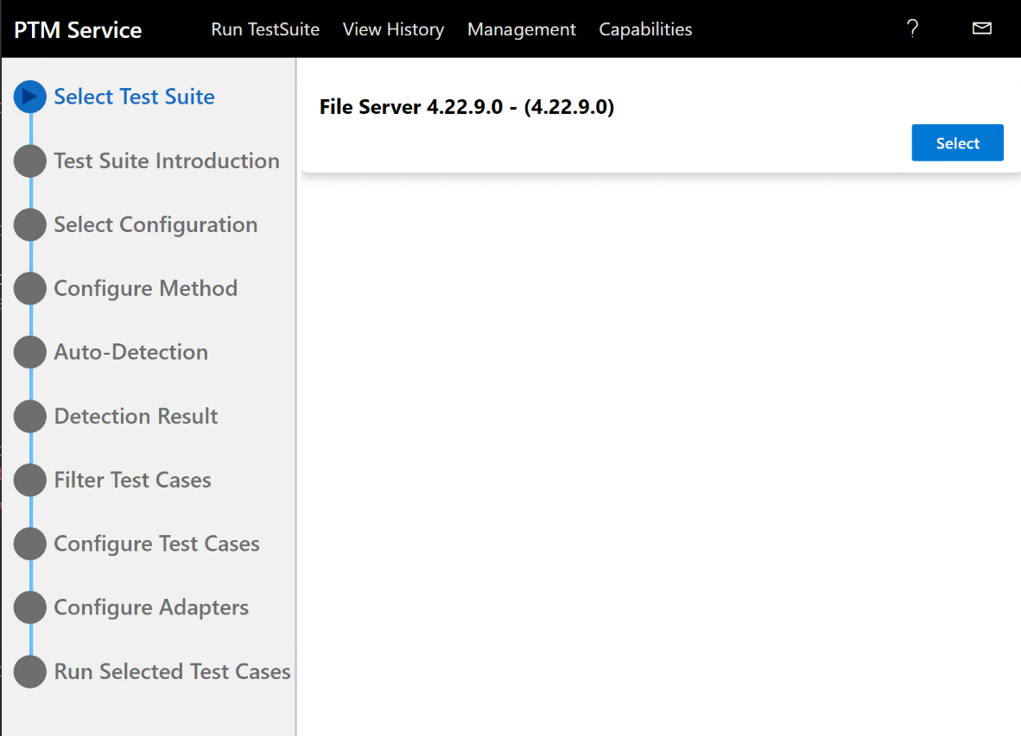
Figure 8. PTM Service : Select Test Suite page
- From the Test Suite Introduction page shown in the following figure (figure 9), familiarize yourself with the family of File Server protocols that comprise the File Server-SMB2 Test Suite.
Note that each of the represented protocols are documented on the Microsoft Technical Documents site. For example, you could review the MS-SMB2 technical specification Overview or you could read the entire document in great detail if you prefer. Neither of these is required to operate the File Server-SMB2 Test Suite. However, a working knowledge of the SMB2 protocol is recommended to fully understand test results.
- Select the Deployment Guide link for optional information about supported test environments, including the Domain and Workgroup environment.

The Workgroup configuration is a facsimile of the test environment architecture described in section 3.4 Test Environment Architecture, that is, with respect to the Driver computer and SUT computer environment.

Note
In the Deployment Guide, performing SUT setup is not required because the work was completed earlier by event support personnel ahead of this tutorial session.
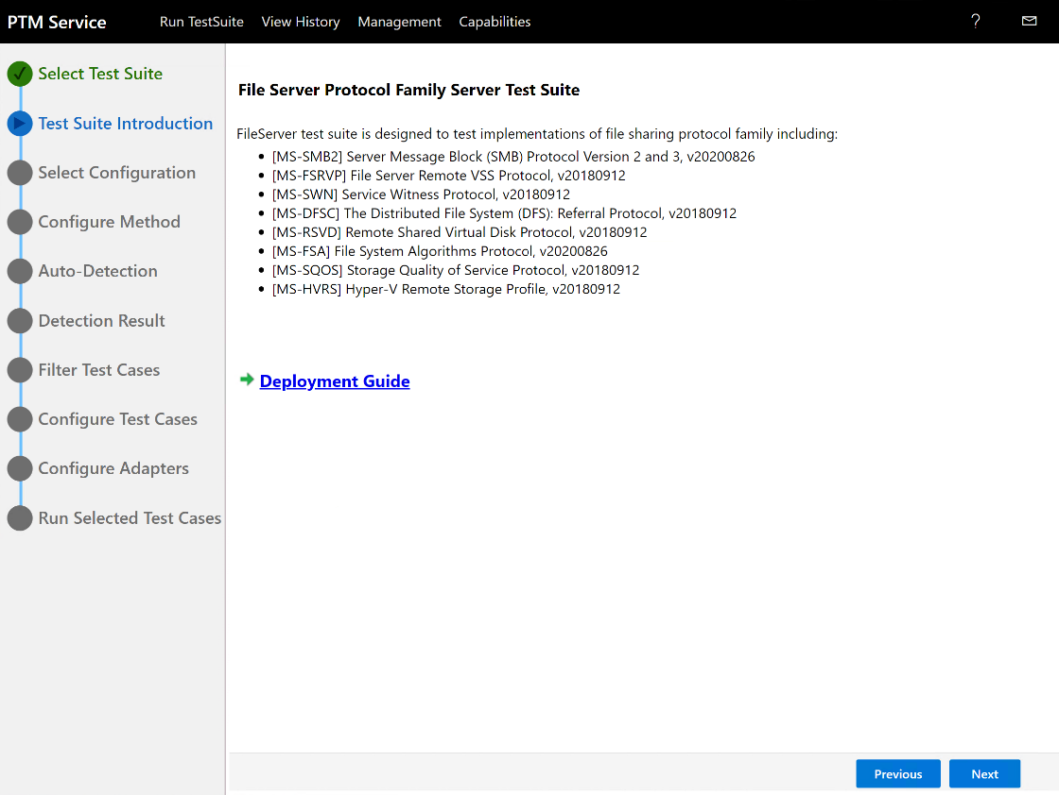
Figure 9. PTM Service: Test Suite Introduction page
Note
The Workgroup environment shown in the following figure (figure 10) is the recommended environment for the tutorial session, as it does not require any configuration. It provides a simple network environment for running the Test Cases that are compatible with the FileServer-SMB2 Test Suite and the PTM Service.
However, outside the Lab session, you are free to use the Domain environment if you prefer. Note that it is more extensive, complex, and would require you to consult the File Server Protocol Family Test Suite User Guide for setup instructions. Also, because the Lab session environment is primarily focused on users that are new to the Test Suites, it is limited for simplicity.

For this reason, several of the protocols that are included in the File Server family of protocols shown in the previous figure (figure 9) are not utilized in this Lab session, as only the MS-SMB2 protocol is used.
Figure 10. PTM Service: Domain and Workgroup environments

- When your optional review of File Server-SMB2 Test Suite environments is complete, select Next to proceed to the Select Configuration page, as shown in the following figure.
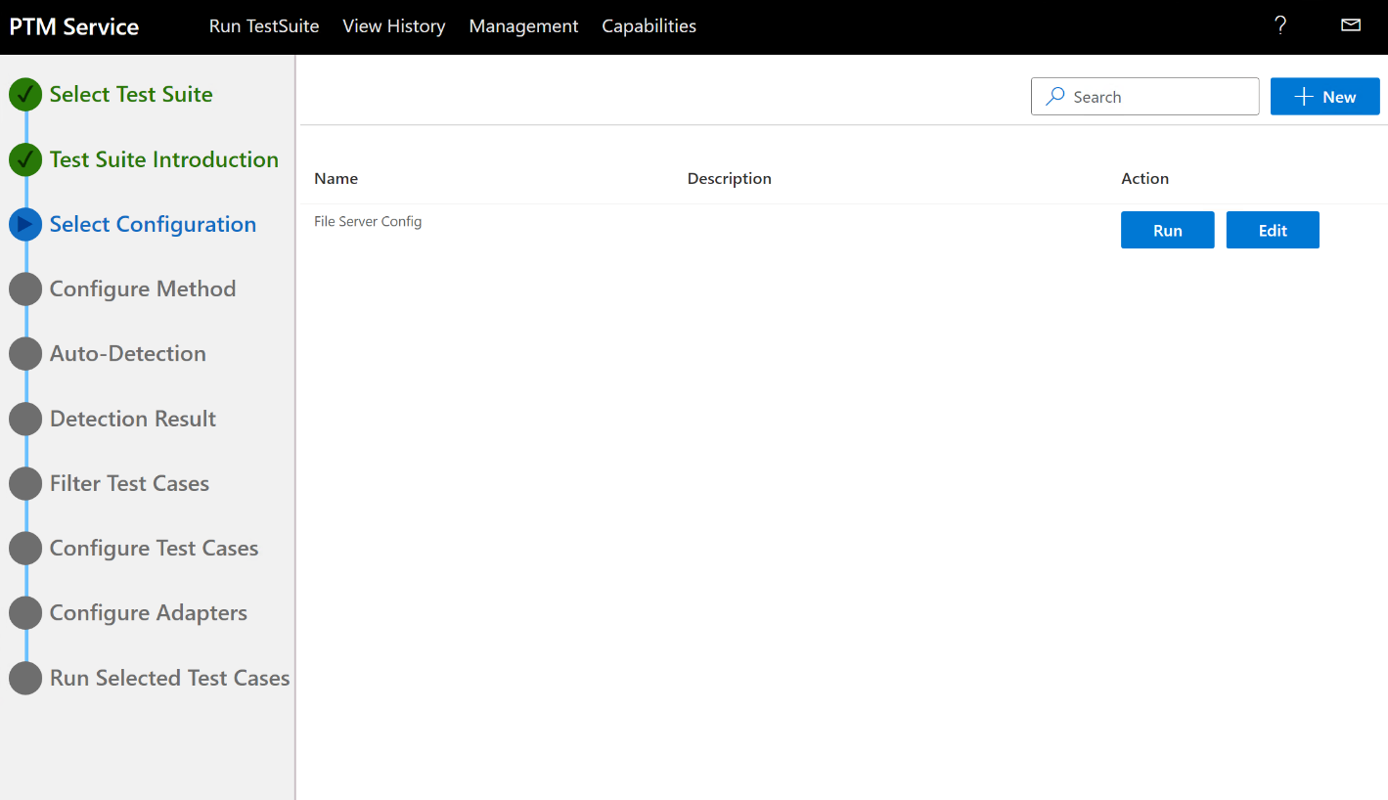Figure 11. PTM Service : Select Configuration page
    - The Select Configuration page of the PTM Service enables you to decide how you want to proceed with Test execution. If you have a named set of Test Cases loaded and configured in the PTM Service, for example, from a prior test run; select the Run button beneath the Action label to restart a previous Test Case execution with no additional configuration required (shown as “Test” under the Name column in the previous figure (figure 11)).

    - Otherwise, select the Edit button to begin Test Suite configuration processes starting with the Configure Method task described in section 4.0 Configuring the Test Suite and shown in the following figure.

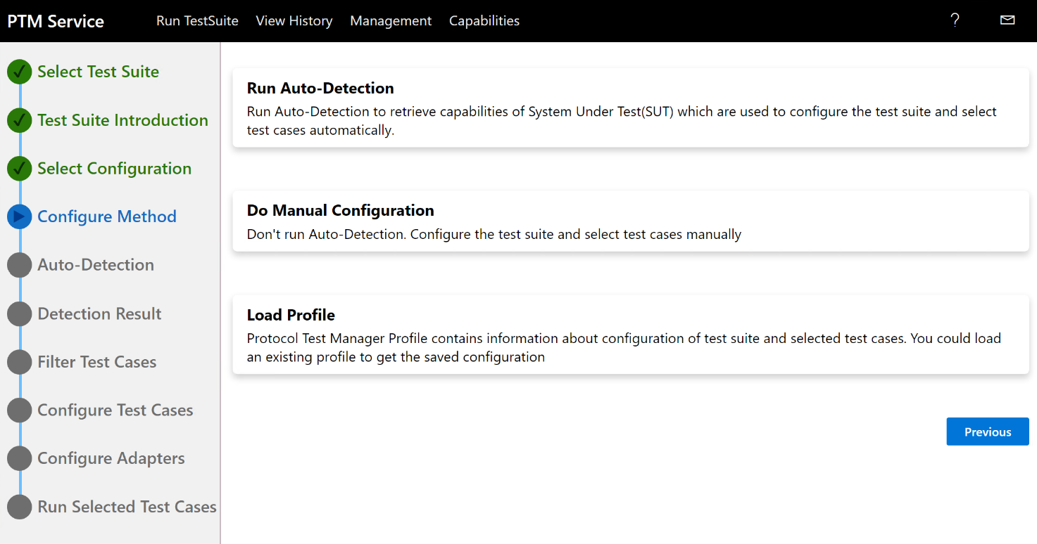
Figure 12. PTM Service : Configure Method page
    - Of the three options presented on the Configure Method page, it is recommended that you select the Run Auto-Detection method. Using the Do Manual Configuration option is not recommended for new users of the File Server-SMB2 Test Suite and it is probable that you have not yet saved a Profile of a test execution configuration that you can rerun.

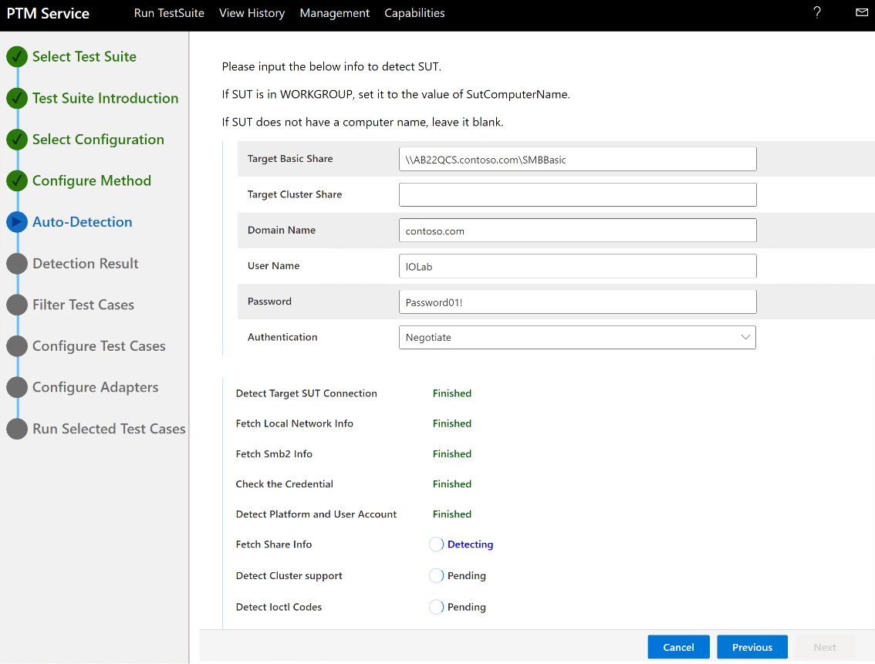
Figure 13. PTM: SUT detection input data
- Configure the Test Suite in accordance with Auto-Detection requirements by following these instructions:
  - On the Auto-Detection page of the PTM Service, ensure that the prerequisite information for auto-detection is correct based on the default values specified in the previous figure (figure 13), (as loaded from .ptfconfig files on the Driver computer), and make any necessary corrections.
If the information to verify is not specified in the Target Share, Domain Name, User Name, or Password text boxes on the Auto-Detection page, consult with your tutorial instructor. If information is displayed, confirm that the values specified on the Auto-Detection page match the Driver computer configuration.

- If the specified information looks correct, select the Detect button on the Auto-Detection page.

Important
The PTM Service on the Driver computer must be able to connect to the SUT computer to make the necessary assessments during the Auto-Detect process, hence the requirement for correct connection data as specified in the previous table. Other connection information is indicated in the following figure (figure 14) as pending processes are completed (as the result of selecting Detect).

- Select the Yes button on the Warning dialog when it appears.
  - After detection has successfully completed, as indicated by the Finished flag next to each item in the lower Auto Detection list, select Next to check the Detection Result.
Note
If any of the Auto-Detection tests fail to confirm as Finished, one or more errors may have occurred that must be corrected. Consult with the tutorial instructor to proceed.

Important
Features that are not supported by the provided SUT test environment, such as Remote Shared Virtual Disk (RSVD), may display the Failure indication whenever an associated information node is expanded on the Detection Result page of the PTM Service. Features that are supported display the Passed indication .

- On the Detection Result page of the PTM Service, as shown in following figure (figure 14), a summary is provided within information nodes. This summary includes Capabilities, SMB2 Compression Feature, SMB2 Encryption Algorithms, IoCtl Codes, Create Contexts, and so on, to indicate what is supported by the SUT configuration that you queried with Auto Detect.

Review this information to ensure that you have a similar result and consult the tutorial instructor if you do not have a similar result.

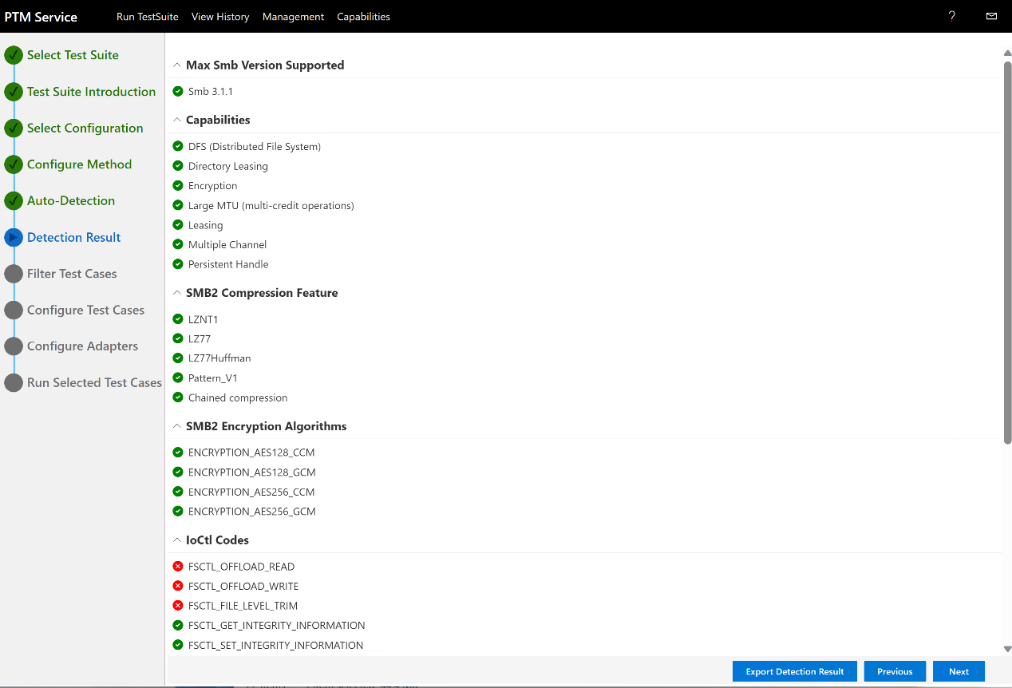
Figure 14. PTM Service : Reviewing Auto Detection results

- Perform clicks on any top-level node to toggle the results and expose or hide result details, respectively.
Note
As you select different feature nodes, a feature description appears in the lower sector of the PTM Service UI.
- When your review is complete, select Next to display the Filter Test Cases page of the PTM Service.

Important
Based on the outcome of the Auto Detect process, the PTM Service will initially display the default Test Cases that support the current configuration of the SUT test environment on the Filter Test Case page, including all supported SMB2 dialects.

However, it is likely that you will be modifying the initial Test Case configuration for the tutorial session environment, as specified by your instructor. For example, your instructor may choose to run the Test Cases specified in section 5.2 Create File Demo.

- In the Selected test cases pane on the Filter Test Case page of PTM Service shown in the following figure (figure 15) observe the display of Test Cases. Note that if the detection results show that your SUT does not support Test Cases for a particular feature, that feature name or the Test Cases may be rendered in italics.

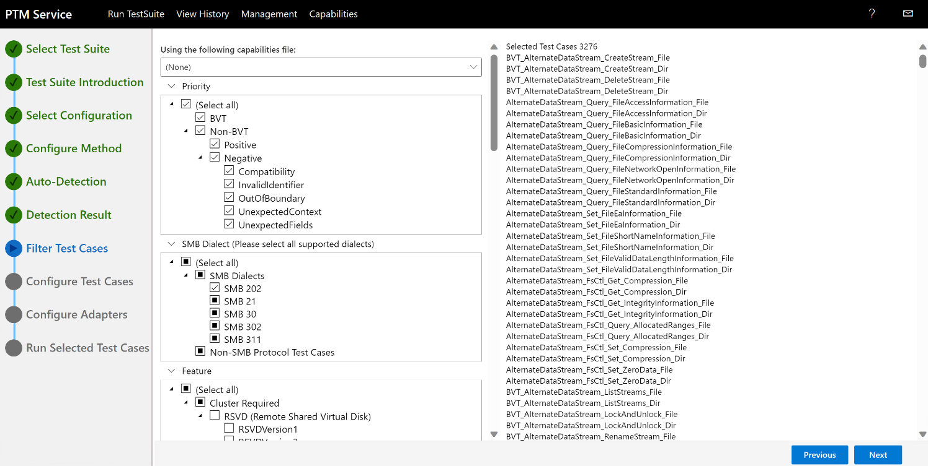
Figure 15. PTM Service: Filtering test cases
Alternatively, you can also filter test cases using capabilities file by selecting desired capabilities file from the list of capabilities file shown in the “Using the following capabilities file” dropdown as shown in the following figure.
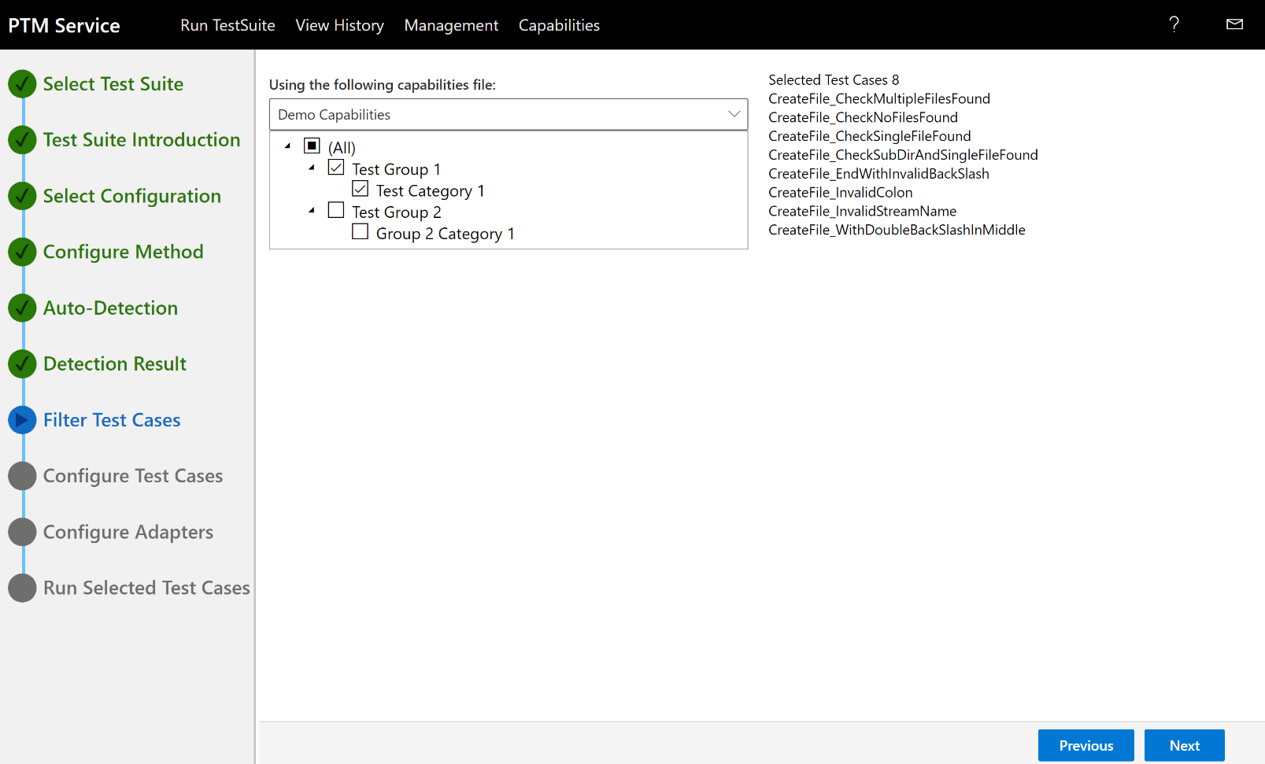
Figure 16. PTM Service: Filtering test cases using capabilities file

More Information
If you want to know more about the functions of specific Test Cases, you can read descriptions in the File Server Protocol Family Test Design Specification.

- In the Priority, SMB Dialect, and Feature panes on the Filter Test Case page, you will manually select or unselect (filter) Test Cases as guided by your tutorial instructor. For brevity in this tutorial session, you will typically configure the PTM Service to run the Test Cases associated with all SMB2 Dialects, those in the BVT category, and a few others.

You should end up with a specified number of tests when complete, as indicated by the instructor. This ensures that you will be running the recommended Test Cases for this tutorial in order to focus on a specific test configuration to obtain a specific test result for analysis. For example, your Instructor may have chosen to run the demo described in section 5.2 Create File Demo.

Select Next when complete to display the Configure Test Cases page of the PTM Service.

- Note
The ‘BVT’ test category name is used to infer the most important tests run by PTM Service, as these are basic tests that include confirming the SUT environment for test readiness.
- On the Configure Test Cases page of the PTM Service as shown in the following figure, verify the correctness of the default property values that were set for the specified Groups, with respect to your detection results. Note that you can edit the values if necessary.
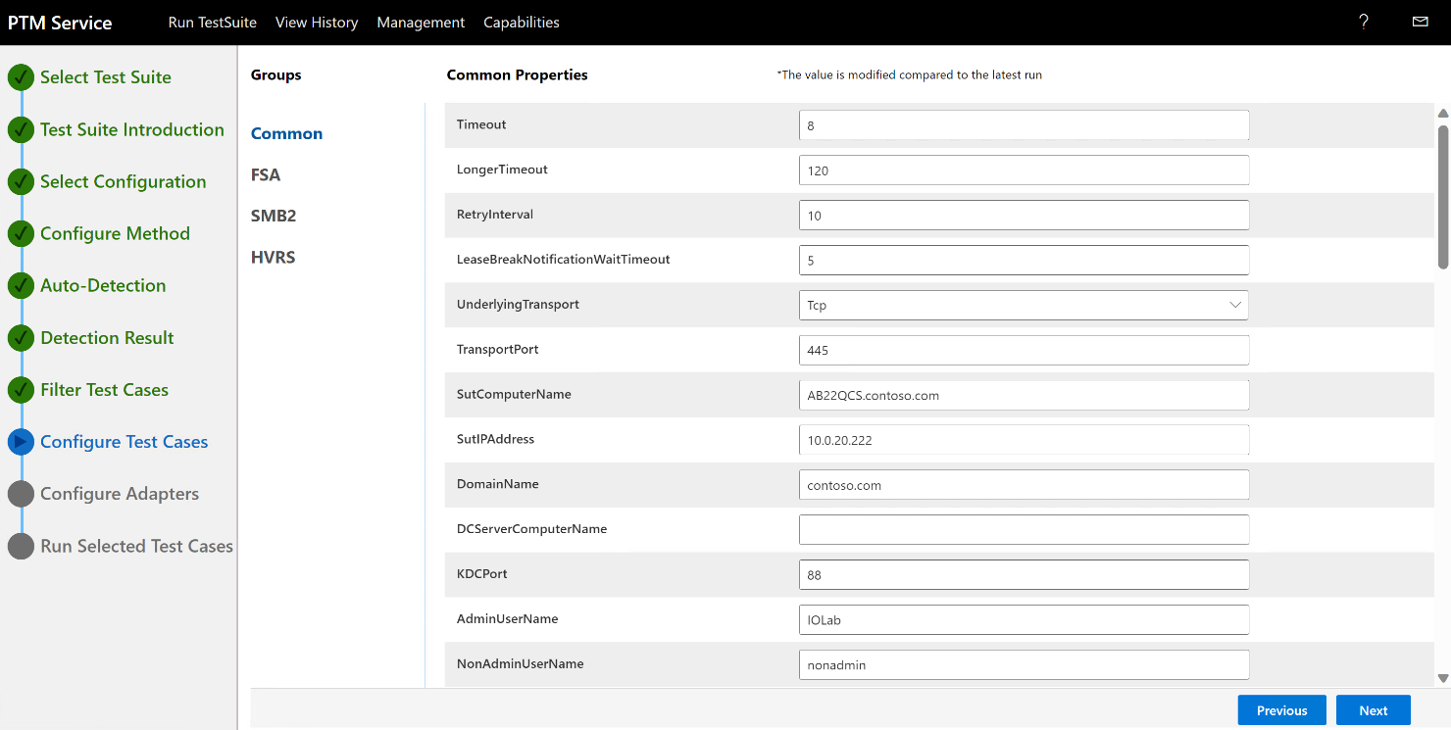
Figure 7. PTM Service : Configure Test Cases page : Common Properties
Advisory
If you edit one or more configuration values, for example in the Common group of the Configure Test Cases page, and you need to recover them later, you can view the default detected values for your environment in the following configuration file on the Driver computer:
C:\FileServer-TestSuite-ServerEP\Bin\CommonTestSuite.Deployment.ptfconfig
Other configuration files for the Test Suite are located in the same directory:
C:\FileServer-TestSuite-ServerEP\Bin\
For example, if you are having difficulty connecting to the SUT computer, you might want to extend the existing LongerTimeout value beyond its default setting. If you decide to reinstate the former default value, you can find it in the previously specified Deployment.ptfconfig file.

Advisory
To view the meaning of the items in the Properties column on the Configure Test Cases page of Protocol Test Manager Service, mouse-hover over any property value to display a pop-up containing the information.
When complete, perform the next step at the discretion of the tutorial instructor only. Otherwise, accept the default settings and select Next.
- On the Configure Adapter page of the PTM Service and from the Type dropdown list of the SUT Protocol control adapter, use the default setting of Managed, as shown in the following figure (figure 18).
Adapters are applications that help trigger events on the SUT that are detected by certain Test Cases. Note that you can ignore the Common SUT control adapter and the Failover SUT control adapter settings, given that tests for these adapters are not run in this tutorial session. Also note that if any other changes are necessary, your tutorial instructor will specify them.
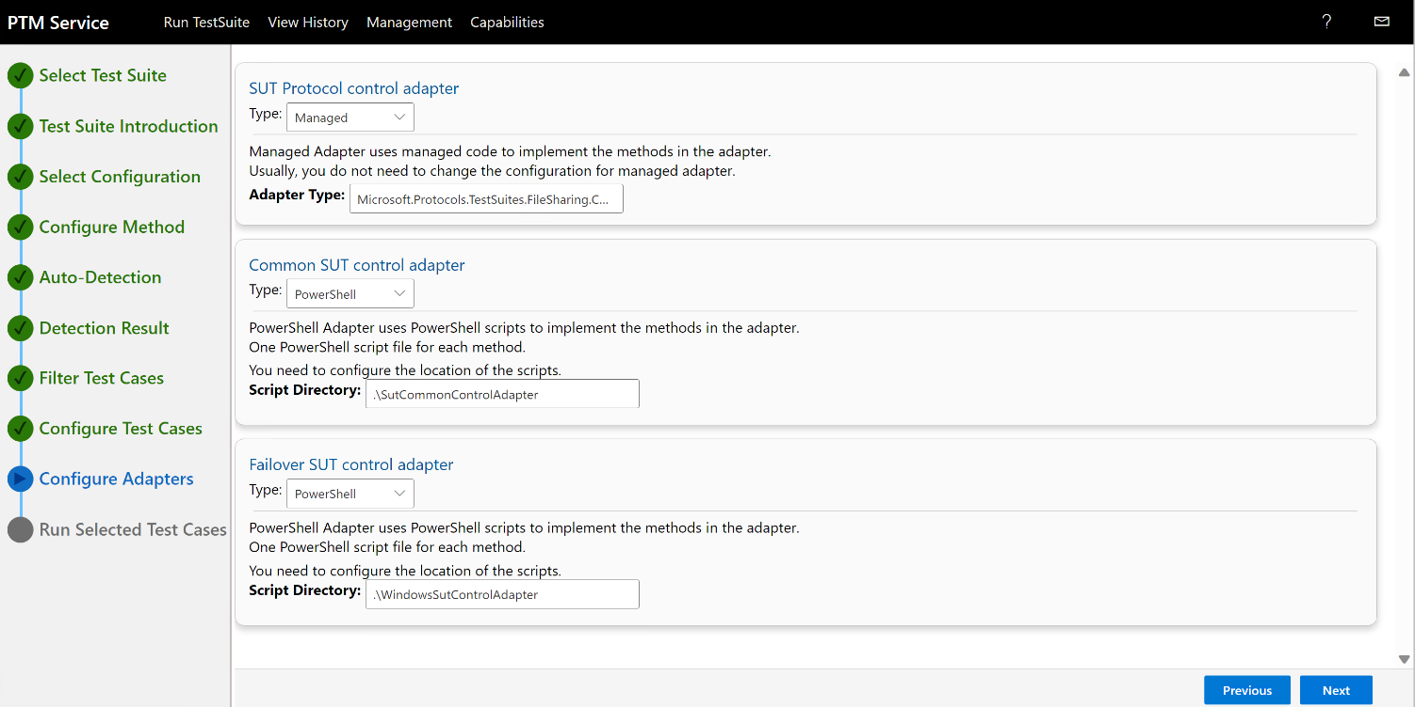
Figure 8. PTM Service: Configuring an SUT control adapter
- Select Next to display the Run Selected Test Cases page of the PTM Service and proceed to section 5.0 Running the Test Suite Test Cases to run your tests.

Note
You may have performed the procedure in the next section earlier, but only if you had already created a Profile in section 5.2 Saving a Profile.

4.2 Configure the Test Environment by Loading a Profile
If you have created one or more Profiles, follow the procedure in this section to load a Profile with the Load Profile option of the PTM Service.
To load a PTM Profile
  - Perform the following steps:
  - On the Configuration Method tab of the PTM Service, select Load Profile, as shown in the following figure (figure 19).
  - Select the open folder icon in the Load Profile dialog that displays.
  - Navigate to and select an existing saved Profile via the Open dialog that displays.
  - Select the Open button in the Open dialog.

- Note
- Your Profiles will be saved in a directory location you choose when performing the procedure in section 5.2 Saving a Profile.
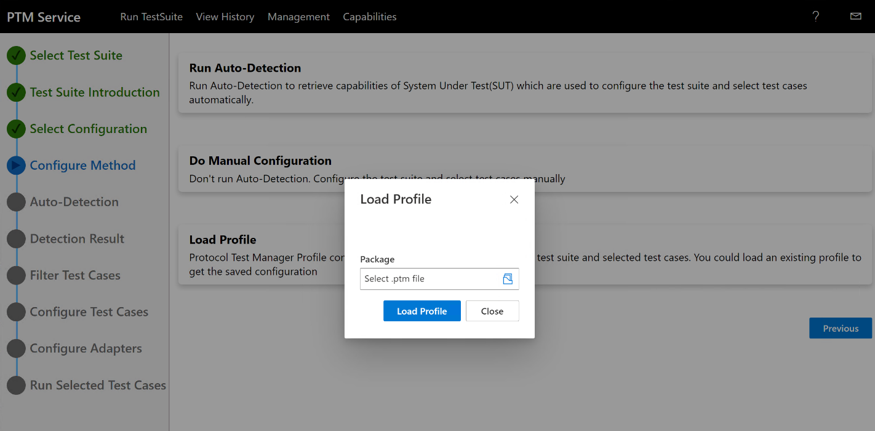
Figure 9. PTM Service : Loading an existing Profile
  - Observe that the PTM Service immediately opens to the Run Selected Test Cases tab with the unexecuted Profile Test Cases displayed, including the expected number of tests indicated.
  - Optionally navigate to the Filter Test Cases tab of the PTM Service and verify that the Test Cases appear as expected from the Profile data that you imported.
Note that you can still modify your selections by selecting or unselecting Test Cases on the Filter Test Cases tab, as necessary.
- Important
If you want to preserve such changes, you must save them by overwriting the existing Profile or by creating a new one.

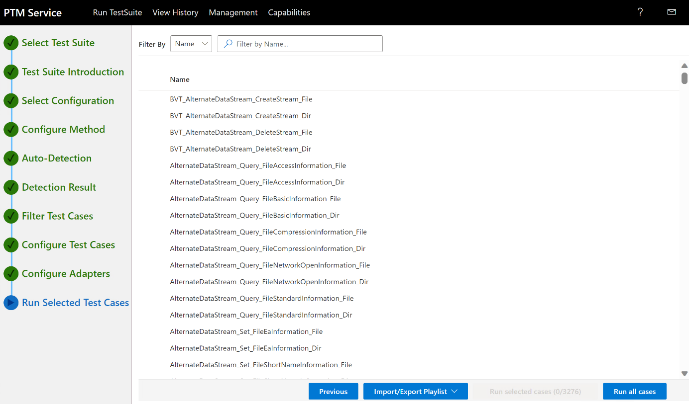
Figure20. PTM Service: Validating Profile test cases prior to execution
- At your discretion, return to the Run Selected Test Cases tab and select Run all cases to execute the Profile Test Cases.

Whether you actually select the Profile Test Cases, all Test Cases will execute when you select Run all cases. If you do select some Profile Test Cases, only the selected Test Cases of the Profile will run after you select Run selected cases.

5.0 Running the Test Suite Test Cases
The following options are available for running Test Cases from the Run Selected Test Cases page of PTM Service. For this tutorial , you will use the latter method of running selected test cases, as specified in the second bullet point below:
Important
DO NOT execute Test Cases now. Only execute from “To run the Test Cases” procedure ahead.

- Run all cases. Select this link to run all Test Cases.
If you select this option, all Test Cases that exist under the Name column on the Run Selected Test Cases page of the PTM Service will be executed, whether you have designated the Test Cases as selected with a checkmark.
These Test Cases are the ones that you selected or filtered earlier on the Filter Test Cases page of the PTM Service and therefore appear on the Run Selected Test Cases page; or they are the Test Cases of an existing Profile, the contents of which you will have loaded into the PTM Service.

Advisory
When you use the Run all cases option, it does not necessarily mean you will be executing all the default Test Cases returned from auto-detection of the SUT configuration. The Run all cases option will execute all the default Test Cases only if you have never modified this default set of Test Cases on the Filter Test Cases.

- Run selected cases. Select this link to run the selected Test Cases.
If you select this option, only the Test Cases that are currently selected will be executed. You can select Test Cases to be run by selecting the radio button to the left of each Test Case, which places a checkmark next to the Test Case name. Any Test Case that is marked as such will be executed when you select Run selected cases, as shown in the following figure.
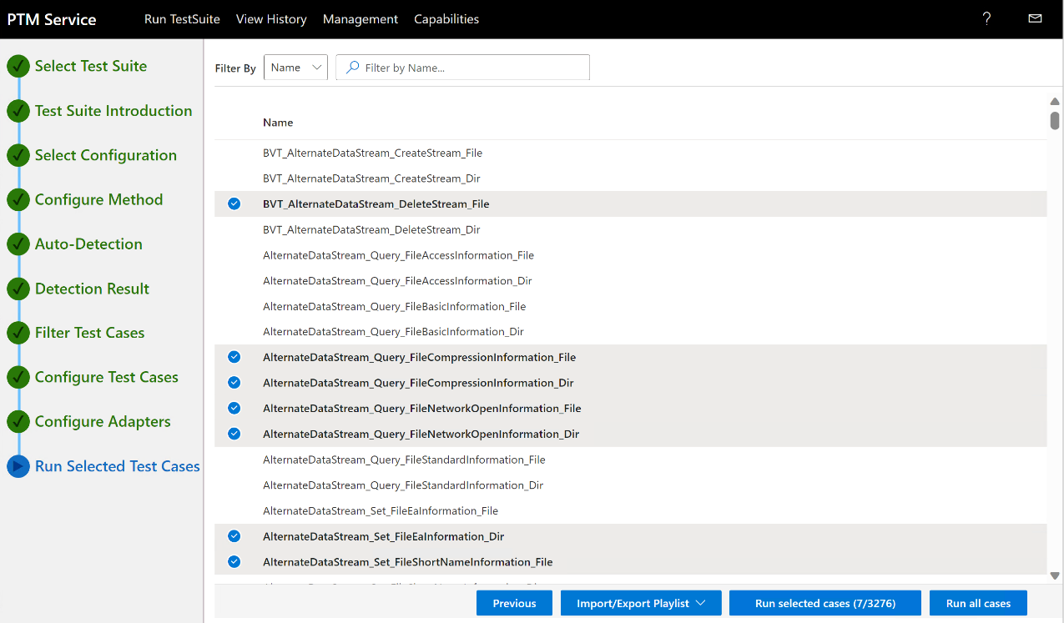
Figure21. PTM Service : Selecting Test Cases to execute
Test Case Execution Status Rankings
As the tests are running, you can view high-level results in the following three categories. As test case execution progresses, you can observe these categories being incrementally updated on the View Result page of the PTM Service, as shown in the figure (figure 22).
- Passed status provides a dynamic indication of how many tests have passed, out of the total number selected for execution.
- Failed status provides a dynamic indication of how many tests have failed, out of the total number selected for execution.
- Inconclusive status indicates the tests that were inappropriate, unsupported, or the result of misconfiguration in the test environment.
For example, if a property set in the CommonTestSuite.Deployment.ptfconfig file is incorrectly configured, or a Test Case conflicts with an unexpected or invalid property value, that Test Case can finish as Inconclusive.
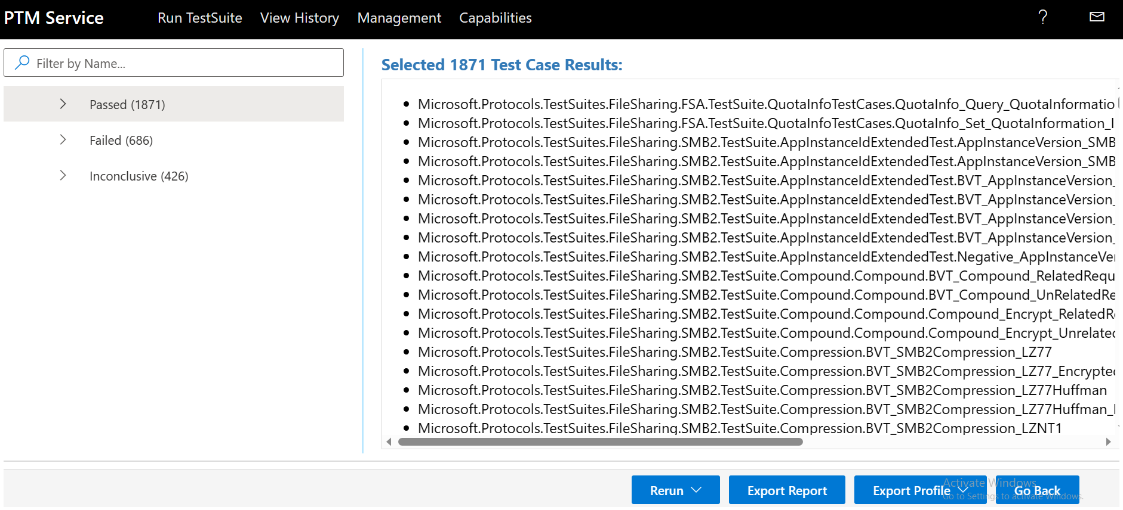
Figure 22. PTM Service : High-level Status Results Categories
Test Case Details
After Test Case execution is complete, you can view the tests in each Status category, by selecting the dropdown arrow next to each set of Status results in the left-hand pane of the PTM Service UI, as shown in the previous figure (figure 22).
Thereafter, you can select a particular Test Case in the left-hand pane in a selected Status category to review information tags, test steps, and other indicators that provide the details that expose the processes that resulted in a Passed, Failed, or Inconclusive status indication for the Test Case you selected; those results display in the rightmost sector of the UI.

More Information
To learn more about analyzing test results, see section 6, Analyzing the Test Results Data in this document.

Import/Export Playlist
On the Run Selected Test Cases page of the PTM Service, you have access to the Import/Export Playlist feature where you can save a set of Test Cases that you can retrieve at any time for test purposes. For example, if you want to retain a unique set of Test Cases that you want to return to for additional testing at a later time, you can use this feature to do so. Note that when you save a playlist with the Import/Export Playlist feature, it does not save Test Case configuration data in the same way that a Profile saves Test Case configuration data. The Import/Export Playlist feature is shown in the following figure.
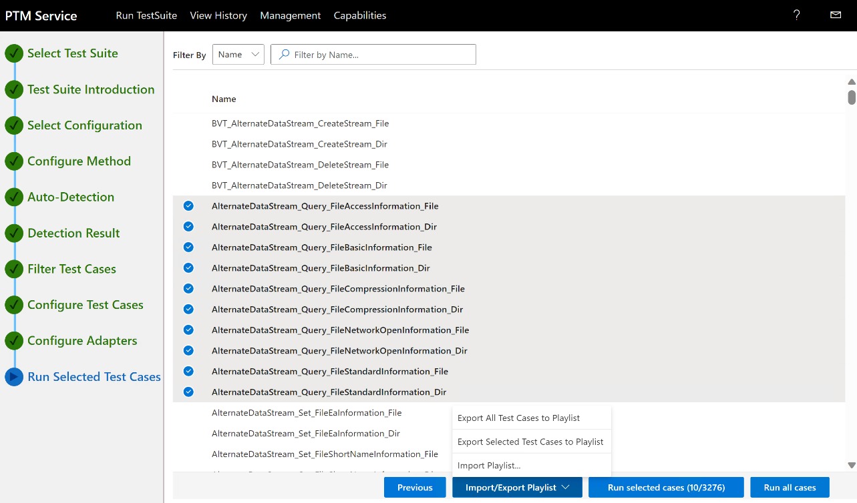
Figure 163. PTMService : Import/Export Playlist feature
From the Import/Export Playlist dropdown button, you can select one of the following three options:
- Export all Test Cases option enables you to export all Test Cases on the Run Selected Test Cases page of the PTM Service.
- Export Selected Test Cases. option enables you to export selected Test Cases only on the Run Selected Test Cases page of the PTM Service.
- Import Playlist option enables you to import all Test Cases saved in either of the two former playlists.

Exporting a Profile for Test Result Comparisons
Note that you can save a Profile (section 5.1 Running the Test Cases) from the View Result page of the PTM Service, by selecting one of the following options from the Export Profile dropdown button:
- Export all Test Cases to Profile option. Select this option if you want to maintain an executable record of a particular test configuration that serves as a baseline for comparing test results following feature fixes, code modifications, updates to Test Case properties, or changes in the SUT computer environment.
- Export Selected Test Cases to Profile option. This option is identical to the previous option but with a narrowed test focus.

5.1 Running the Test Cases
Perform the procedure that follows to run the Test Cases.

To run the Test Cases:

- From the Run Selected Test Cases page of the PTM Service, you can do either of the following at any one time:

  - Run all cases. Select this option if you want to run all Test Cases currently displayed on the Run Selected Test Cases page.

You might do a first run to get a general sense of what the Status is across the current set of Test Cases before you begin isolating specific test areas you want to focus on. For example, if you are getting a lot of failures; potentially with core file operation Test Cases, it can call your attention to more urgent issues that you may need to address first.

  - Run selected cases. Select this option if you want to run only the Test Cases that you have flagged with a check mark, as described earlier.

This enables you to create a specific configuration of Test Cases that targets a particular function or feature that you want to isolate for testing and remediation. Then, you could choose Run all cases again to see if you made improvements in failure Status.

In practice, you could name two test configurations (or just use their configuration IDs on the View History page) and run one against all Test Cases as a status run and the other against selected Test Cases for a focus run. After you remediate any issues, you can run each of these again by selecting the Re-Run button for each test configuration on the View History page, as accessible from the PTM Service ribbon. You can do this as many times as necessary while you monitor improvements or regressions.

- If you have selected Test Cases on the Run Selected Test Cases page of the PTM Service, as designated by checkmarks, select the Run selected cases button for test execution, as represented in the following figure (figure 24). Only the selected subset of Test Cases will execute.

Note
If you have selected Test Cases on the Run Selected Test Cases page and you select Run all cases, then all Test Cases present will execute regardless of any checkmark designations. However, if you have no checkmark designations on any Test Cases, only the Run all cases option will be available for test execution.

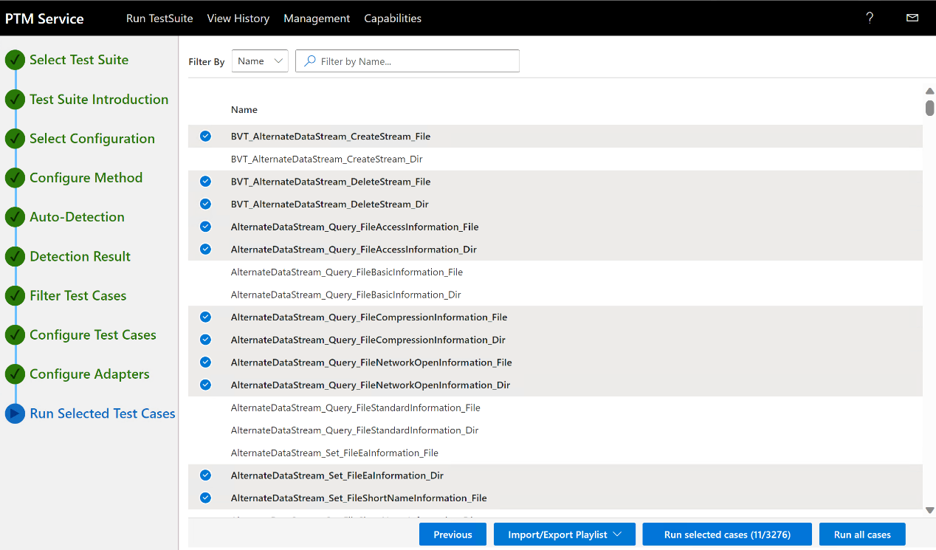
Figure 174. PTM Service : Executing selected Test Cases

- While your Test Cases are running as shown under Status on the test execution View History page that follows, locate the View Result button on the right-hand sector of this page and select it to display the View Results page to review status and other execution details.

Note that you can also access the View Result page from the PTM Service landing page.

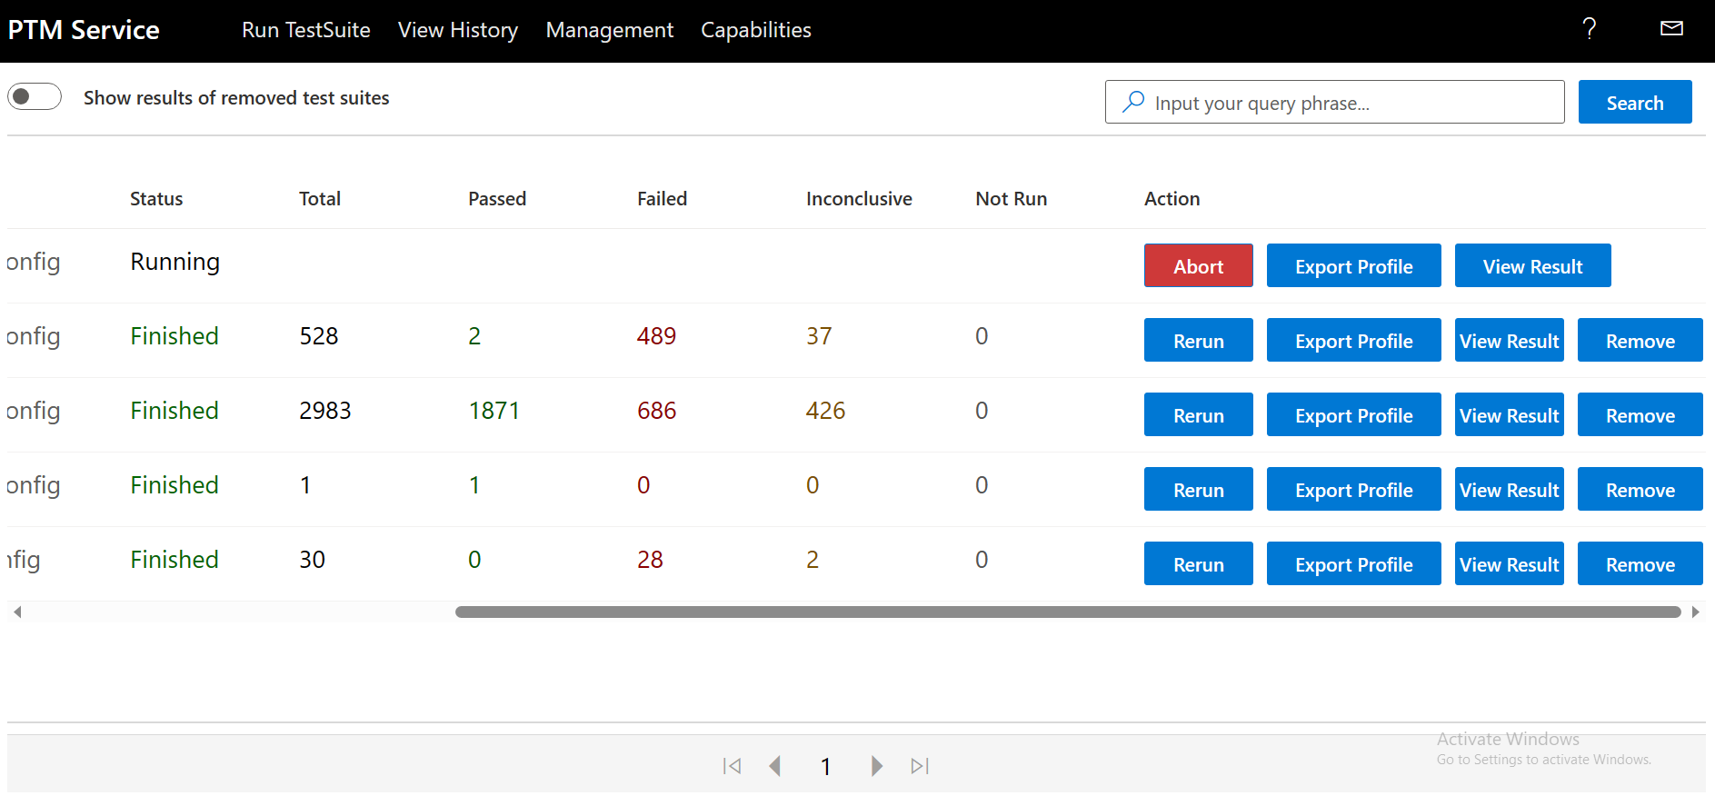
Figure 185. PTM Service: Test execution History view
- As Test Cases execute, observe the incremental indications that appear in the Passed, Failed, and Inconclusive dropdown Status categories as the number of tests in each category are enumerated, as shown in parentheses on the View Results page that follows.
- In the Failure Status category, select a Test Case in the leftmost pane of the View Results page of the PTM Service, as indicated in the example of the following figure (figure 26). If you don’t see the failure that occurred right away, as highlighted in red, you may need to scroll down until you do.
- After a Test Case executes, you can delete the result by selecting the Remove button on the rightmost side of the Test Case result as shown in figure 25 above. This deletes the Test Case result and this process cannot be reversed.

Advisory
The importance of a failure is often discovered in the steps that lead up to the failure. That is why the PTM Service provides information tags that can expose key values, conditions, test steps, check points, and comments that can help point the way in your troubleshooting process.
The meaning of the information tags are discussed further in section 6.1 Test Results Output Status Indicators. However a few information tags are listed here as an example:
  - [TestInProgress]
  - [Comment]
  - [Debug]
  - [CheckPoint]

Note that the PTM Service UI makes your test results more accessible, comprehensible, and consistent through categorization, summaries, and status indicators.

More Information
To learn more about analyzing the results of Test Case execution, where the details of each Test Case starts with a description of what it actually tested, see section 6.0 Analyzing the Test Results.
To learn more about Test Cases and how tests are performed, review their descriptions in the File Server Protocol Family Test Design Specification.

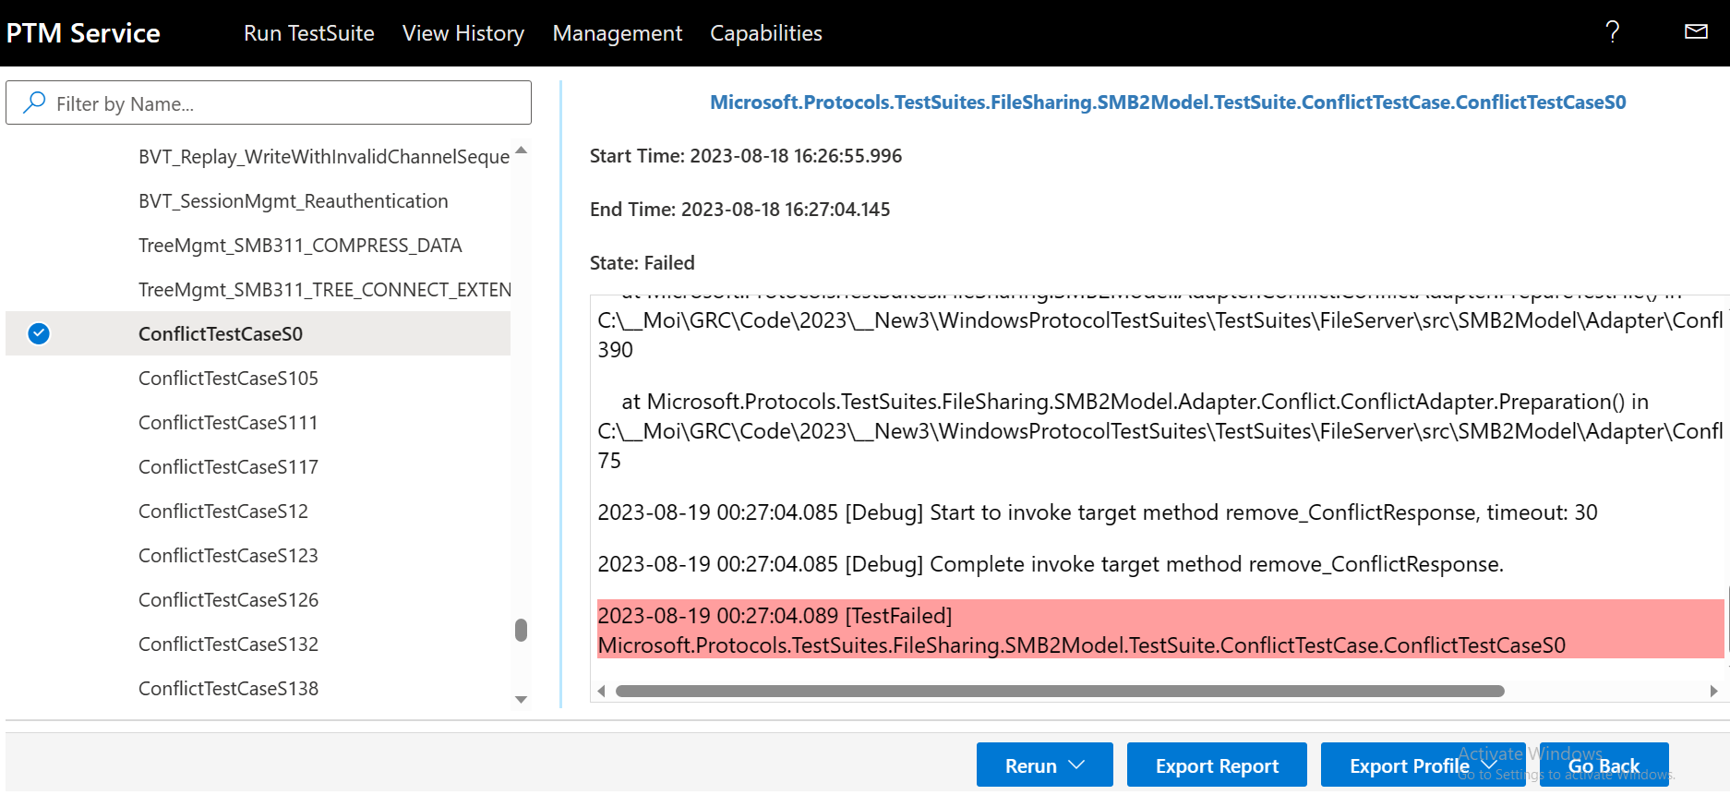
Figure 196. PTM Service : View Results page

Create File Demo
In this section, you will run a Test Case for creating a file. You can begin by performing the procedure that follows:
To Create the Test Case configuration for creating a file
- From the Filter Test Cases page of the PTM Service, perform these steps:
- Choose Select All to unselect all Test Cases.
- Select the Non-BVT node and then select the Positive subnode.
- Under SMB dialects, select the Non-SMB protocol Test Cases node.
- Under the top-level Others node, scroll down to the FSA node and then select the CreateFile test case.
- When complete, you should see a set of 30 Test Cases in the rightmost pane of the Filter Test Cases page of the PTM Service, as shown in the following figure (figure 27).
- At this point, you should await further guidance from the tutorial instructor.

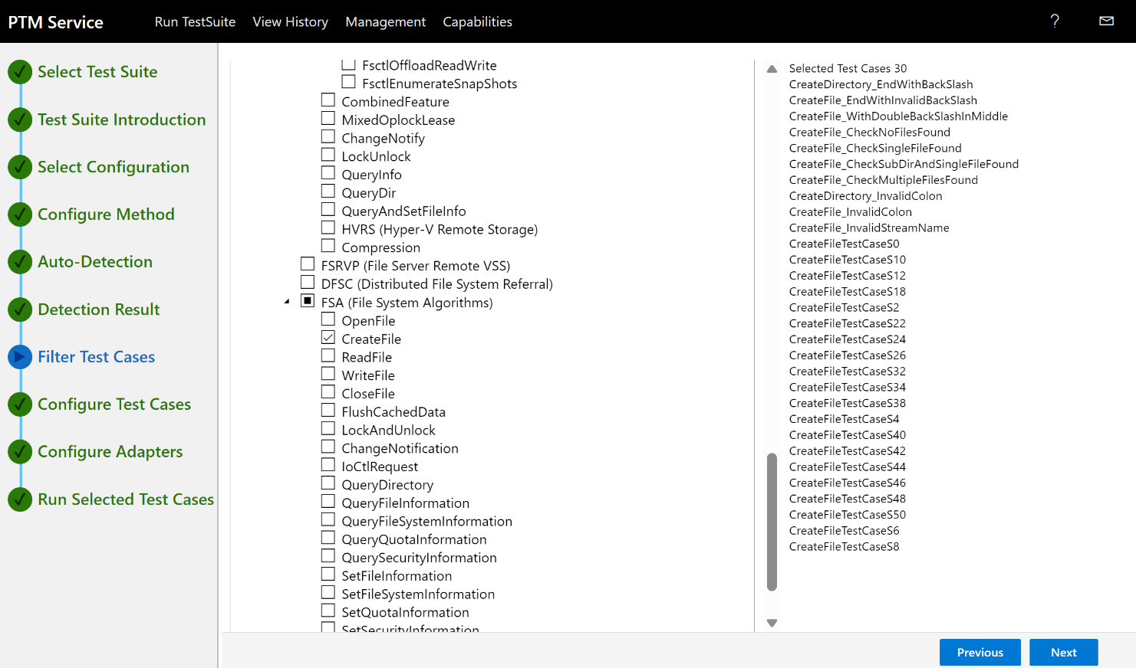
Figure 207. Create file demo

5.3 Saving a Profile
After you complete a test run in section 5.0 Running the Test Suite Test Cases, based on a particular Test Case configuration, you have the option to use the PTM Service to save the configuration as a Profile that you can rerun on demand simply by locating the Profile in a specified directory, loading it into the PTM Service, and then executing it.
Thereafter, you can analyze the data in the same way you would normally do during any analysis session that you started based on the Auto-Detect mode, as described in section 4.1 Configure the Test Environment with the PTM Service.
To utilize a Profile in the stated manner, it is recommended that you run the Test Suite at least once and save a Profile that extracts the test cases you selected along with related configuration information.
However, in real world scenarios, note that you can optionally save a Profile before executing your Test Case configuration. However, in this case, you will not have the advantage of knowing how well the Test Case configuration performed and whether you really want to save it, for example, as a test results baseline for a certain set of features you plan to retest for comparison purposes.
After you save a Profile, you can then use it in subsequent reruns of the profiled test environment where you specify use of the Load Profile option in the PTM Service.
Instructions on how to save a Profile are as follows.
To save a Profile that encapsulates the current Test Case configuration
- In the lower-right sector of the View Result page of the PTM Service shown in the following figure (figure 28), select the Export Profile dropdown button to display the following command selections:
  - Export all Test Cases to Profile. Select if you want to generate an executable record of a particular test configuration based on the current test run, that reflects a specific environment of interest you want to preserve for test purposes.
You might do this to facilitate a record of test performance that creates a baseline for future test result comparisons.
  - Export Selected Test Cases to Profile. Identical as above but with a narrowed test focus of selected Test Cases.

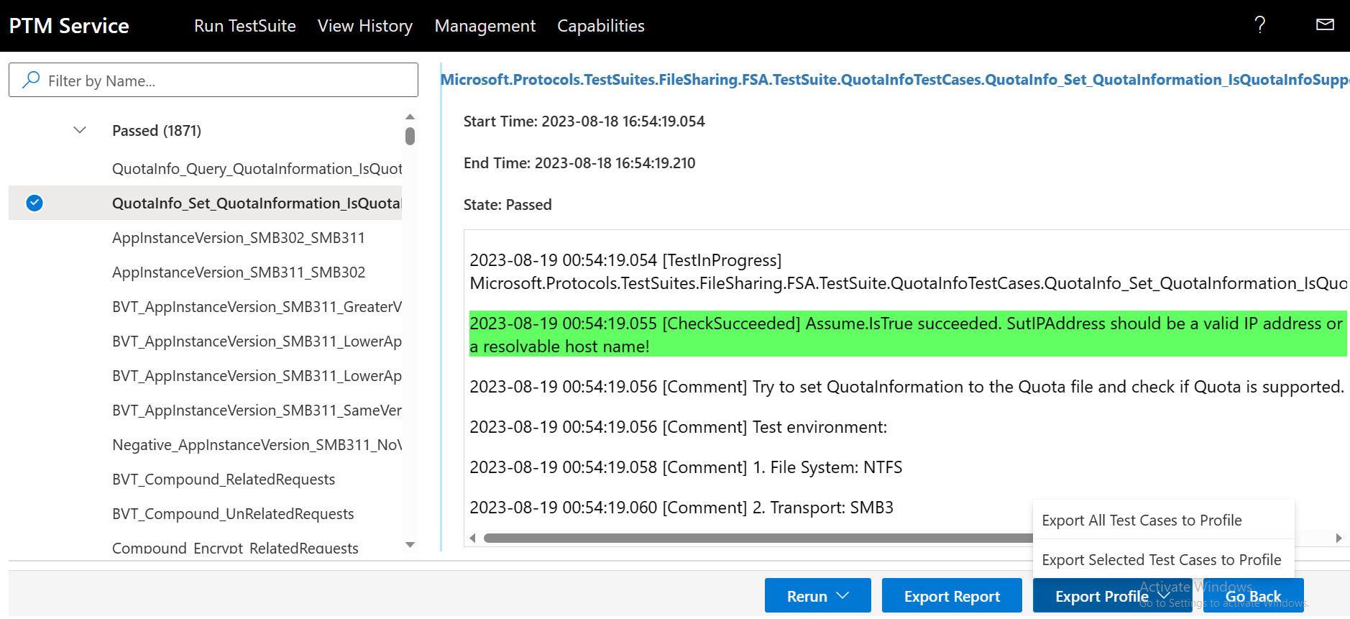
Figure 218. PTM Service : Saving a Test Cases Profile
This action should post the Profile to a Downloads dialog that is invoked by the PTM Service.
- Open the Downloads folder in your file system for access to the file.
- If you want to create a separate directory location for all your saved Profiles, navigate to a chosen directory location for the Profile via a Save dialog, specify an appropriate Profile name, select Save, and then close the open Save dialog.

5.4 Create Capabilities File
Capabilities Files are used to filter Test Cases using a more granular description of the desired Test Cases. Capabilities Files can be used to filter Test Cases on the PTM Service and PTM CLI.
To create a capability file
- On the PTM Service header pane, select the linked Capabilities tab to display the Capabilities page as shown in the following figure (figure 29).
- Select the New Capabilities File button on the top right corner of the page. The Create Capabilities File form will open as shown in figure 29.
  - Enter a Capabilities File name
  - Select appropriate Test Suite
  - Enter Capabilities File description (optional)

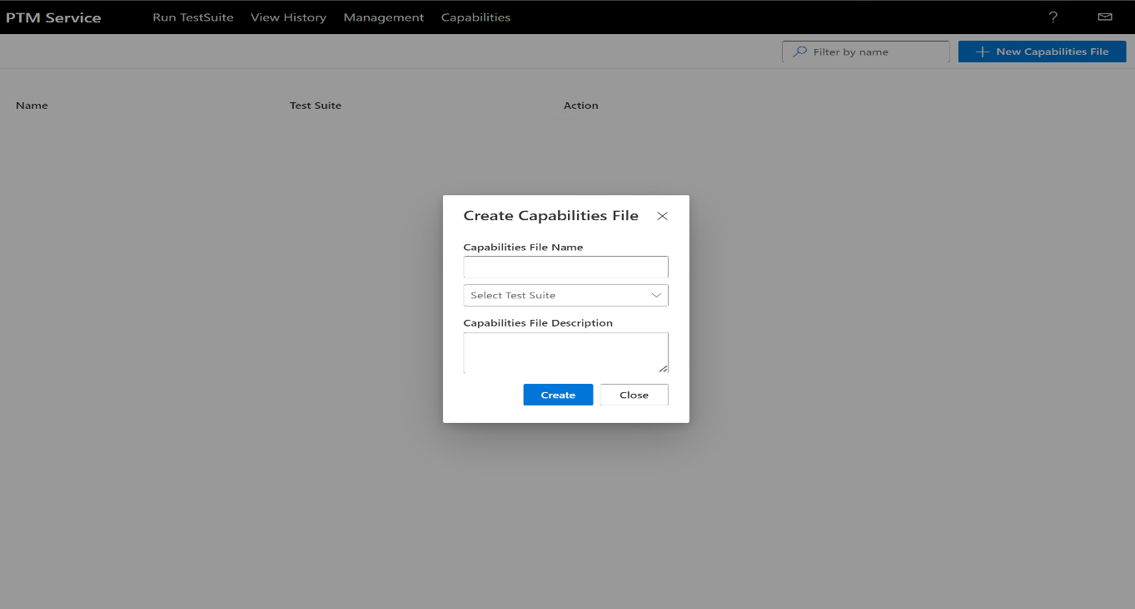
Figure 29. PTM Service : Create Capabilities File

- To manage the Capabilities File, select the Configure button under the Action column of the desired Capabilities File as shown in the following figure.
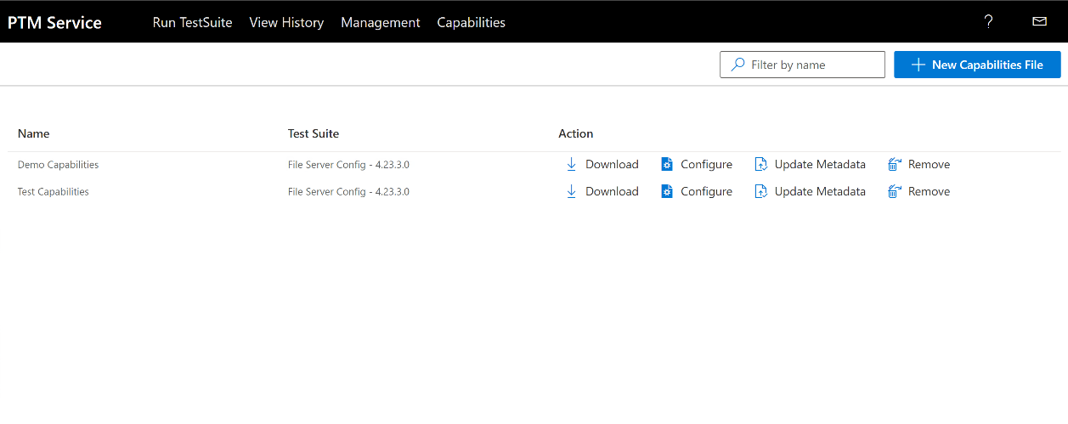
Figure 3022. PTM Service: Configure Capabilities File

- In the Capabilities File configuration page, select the Group menu on the top left corner and choose New Group as shown in figure 31. Enter a Group name and select the Create button. You can create as many groups as you need.

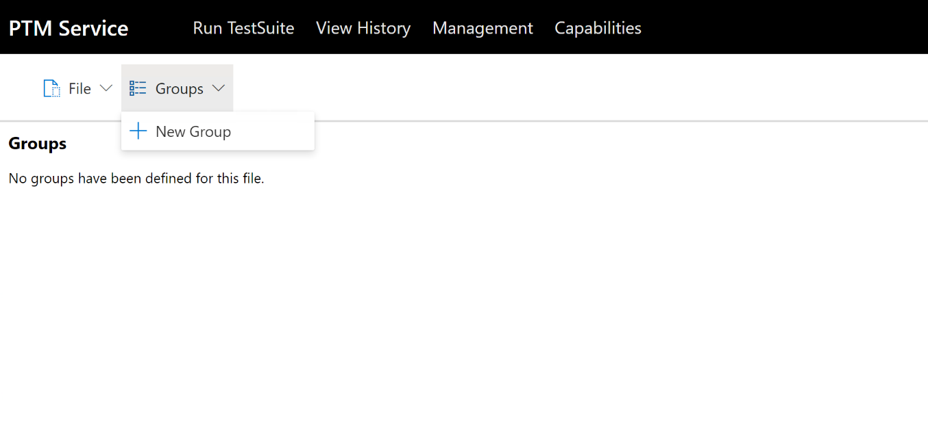
Figure 31. PTM Service: New Group for capabilities file

- Select the appropriate test Group, then select the Categories menu on the top left corner of the page as shown in figure 32. Select the New Category button. Enter the category name and select Create.
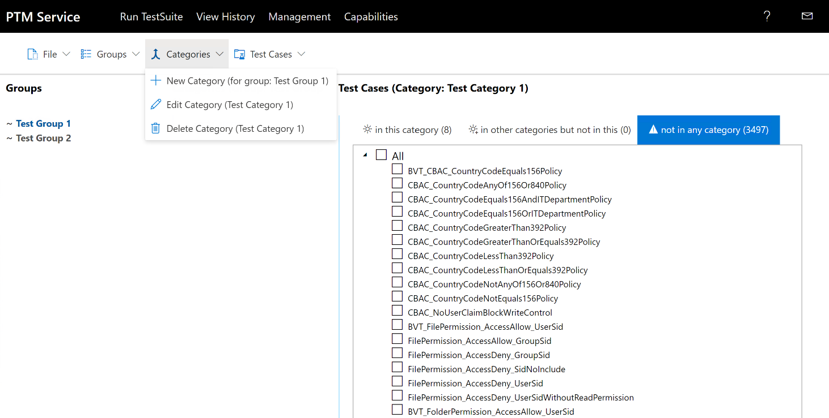
Figure 32. PTM Service: New Category for capabilities file

- Select the Not in any category tab on the right pane. Then, select Test Cases that you would like to add to the current category by expanding the All tree and checking the appropriate Test Cases as shown in the following figure (figure 33). You can check the All checkbox to select all Test Cases. Select the Test Cases menu on the top left corner of the page, then choose the Add the selected test case(s) to category ‘category name’. The selected Test Cases will appear in the In this category tab of the Groups pane. You can create as many categories for each group as needed.
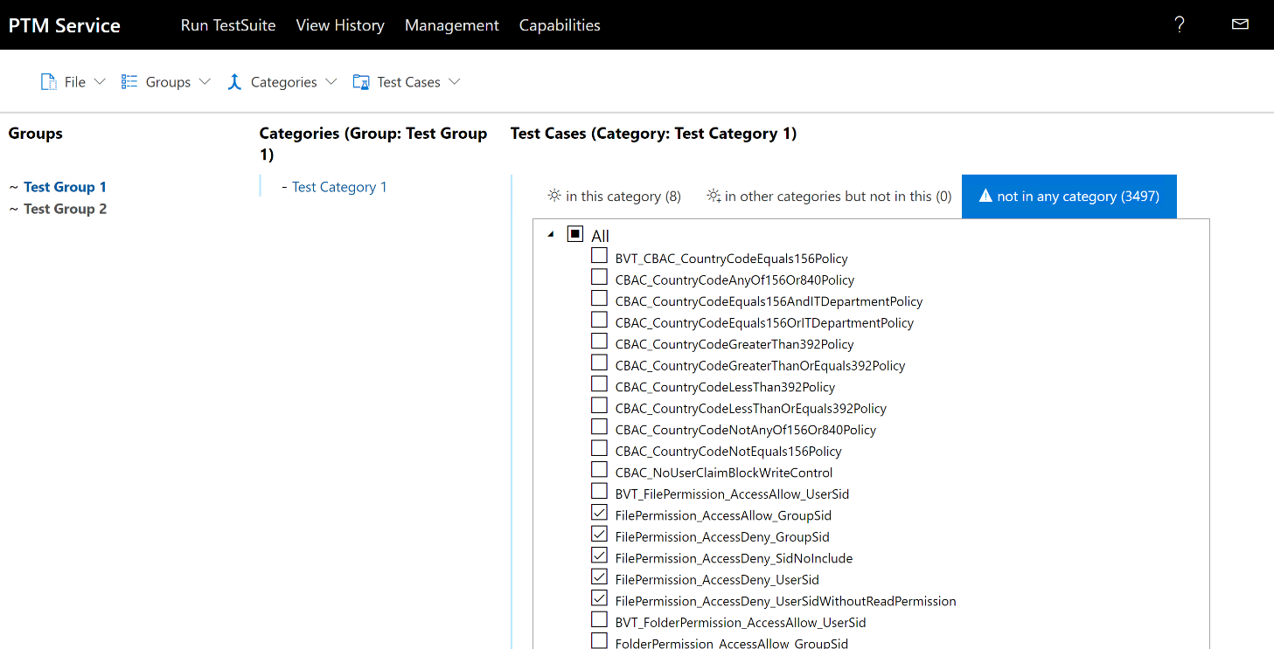
Figure 33. PTM Service: Add test cases to capabilities file

- Save the Capabilities File by selecting the File menu on the top left corner of the page as shown in the following figure (figure 34) and select Save. The Capabilities File is persisted in the PTM Service database. You can download the Capabilities File by selecting Download. The Capabilities File is downloaded as a Json file that can be used to filter Test Cases on the PTM Service or PTM CLI. Section 4.1 Step 13 shows how to use Capabilities File in PTM Service while Section 5.5 Step 2 shows how to use Capabilities File in PTM CLI.
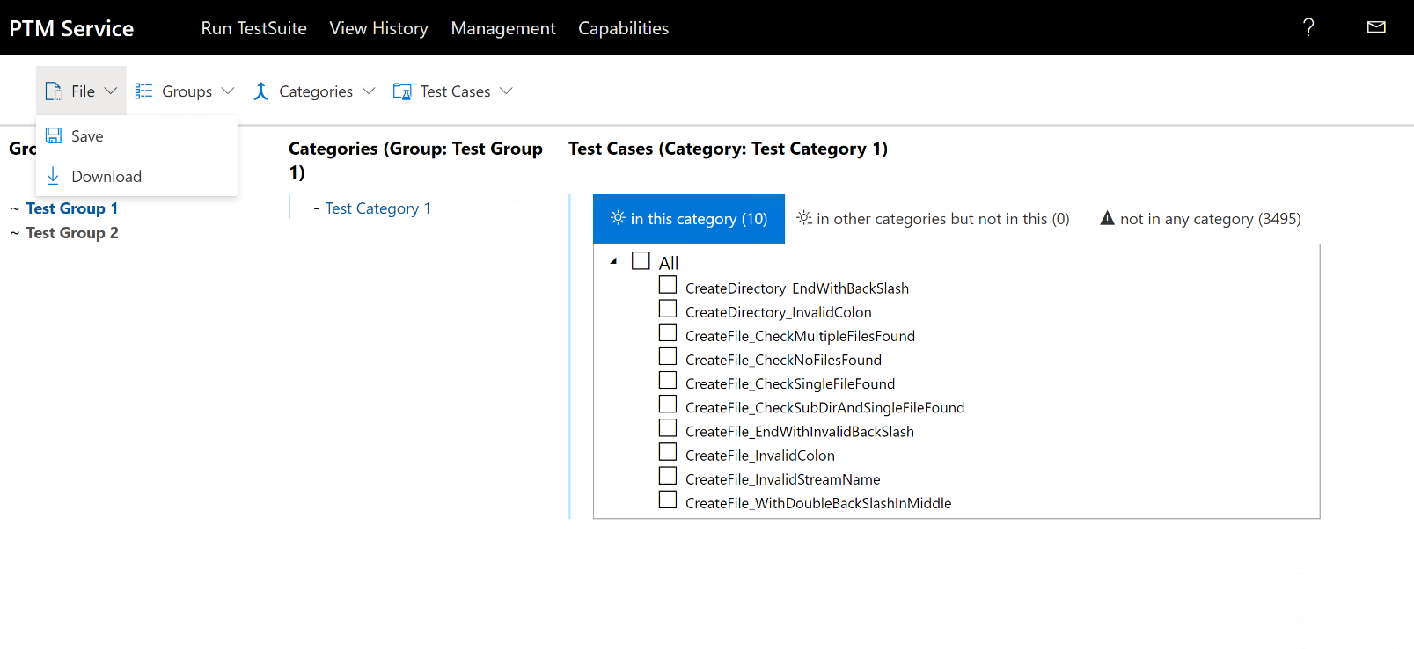
Figure 34. PTM Service: Save capabilities file

5.5 Executing Test Cases From the Command Line
The PTM Command line interface (PTMCLI) application enables you execute the Test Case configuration of a previously saved Profile (section 5.2 Create File Demo) with the use of a simple command string. This means you can initiate execution of a set of Test Cases from outside the PTM Service UI test environment and potentially from a remote location.
The application that enables you to do this is known as PTMCli.exe. This file resides in the following directory path on the Driver computer:
C:\PTMCli\PtmCli.exe
To execute the Test Cases of a Profile by using a command string, perform the procedure below:

- Important
You should not run the PtmCli.exe application while the PTM Service is running or an error will occur.

To load a Profile from the command line
- From the Start menu on the Driver computer, type “Cmd” and then double-click the Command Prompt icon. You can also run the command shell with the elevated privilege of an Administrator.
- From the command line, navigate to the following directory location on the Driver computer:
C:\PTMCli\
The command string to start the PTMCli executable uses the following format, where -p and -t switch variables require specific values that you must supply, as follows:
PTMCli.exe -p <profilepath> -s -t <testsuitepath> -cFilter -cFile <capabilitiesfilepath>
Other switches and values for the preceding command string are specified in the following table.

Table 2. PTMCli command line switches and values
Switch | Switch Value | Description
-p | Represents profile execution | Requires a directory path to a saved Profile.
-s | Represents Test Case execution | Optional – if used, only selected Profile Cases execute; if not used, all Profile Cases execute.
-t | Represents hosting Test Suite | Requires a directory path to File Server Test Suite.
-r | Represents a test execution report | Optional – if used, generates a Report to specified path; if not used, output is stdout.
--cFile | Represents a Capabilities File path | Optional- Specifies the path to the capabilities specification file to use.
--cFilter | Represents a Capabilities File filter | Optional – if used, only test cases added to the Capabilities File are executed. Required if a capabilities specification file is provided using the cFile parameter.

For example, to execute PTMCli.exe from the Driver computer, enter the command:
.\PTMCli.exe -p C:\PTMCli\<TestCaseProfile.ptm> -s -t C:\FileServer-TestSuite-ServerEP\
To execute PTMCli.exe from the Driver computer using Capabilities File, enter the command:
.\PTMCli.exe -p C:\PTMCli\<TestCaseProfile.ptm> -t C:\FileServer-TestSuite-ServerEP\ --cfile "..\cspec.json" --cfilter "Test Group 1.Test Category 1"
- Select the Enter key on your keyboard and confirm that the Test Case execution results begin to appear in the command console.
Note
For additional information about functionality that is available with the PTMCli tool, use the -help switch to display it:
PTMCli.exe -help
You can also find additional help on PTMCli.exe and related topics here on GitHub.

6.0 Analyzing the Test Results Data
After Test Case execution is complete, you can view the details of the execution results. The results that are likely to be of the most interest are the Test Cases that failed. The Test Cases that finished as inconclusive can also be of interest, as these might suggest misconfigurations, such as invalid Test Case properties or settings. The PTM Service provides several tools that can quickly point you to the potential causes of such failures and misconfigurations.
The PTM Service enables you to utilize various status indicators, color codings, information tags, and results filtering that can help you expose the cause of failures.
In addition, you should consider that specifying chosen Test Cases on the Filter Test Cases page of the PTM Service is a troubleshooting tool that you can utilize. This technique helps you to target specific areas that you want to isolate to generate a more focused test results context. For example, you might focus on certain SMB2 operations that you suspect could be problematic or even specific SMB dialects for which you want to expose test results.

Note
Outside the space of this tutorial and associated lab environment, developers who are using a Microsoft Test Suite to test a real-world protocol implementation can similarly utilize the PTM Service analysis features to verify the outcome of custom Test Case execution as Passed, Failed, or Inconclusive. Each of these indications can be of equal importance when it comes to resolving issues that are critical to a successfully functioning protocol.

6.1 Test Results Output and Status Indicators
Some of the status indicators that you will encounter as you review your test results are described in the following table.

Table 3. Test results status indicators
Status Indicator | Description | UI Location
Initial Test Results Status summary | Results display as the number of Test Cases that passed, failed, or were inconclusive. | The initial Test Case results display configuration is shown as expandable Passed, Failed, and Inconclusive results category dropdown lists in the leftmost sector of the View Results page of the PTM Service.
Detailed Results | Appears as the default Test Case output configuration on the View Results page of the PTM Service. | The results of a Test Case appear in the rightmost sector of the View Results page of the PTM Service, that is, when the case is selected in the leftmost sector of the same page.  For example, the result details typically begin with a [TestInProgress] information tag followed by a [Comment] tag that describes the general purpose of the Test Case. It then exposes the sequence in which [TestSteps] executed, which can be interleaved with one or more [Debug] tags for each [TestStep], which reflects invoked methods, process data, or status resulting from the step. Also, checks are made along the way which result in either a [CheckSucceeded] or [CheckFailed] outcome.. The final result of the Test Case could be a [TestPassed], [TestFailed], or [TestInconclusive] indication.
Start Time and End Time | Exposes the overall duration of Test Case execution. | Appears in the upper left-hand sector of the Test details pane of the View Results page for each selected Test Case in every results category.
Filtered Test Case contexts | Consists of the results for specifically chosen Test Cases either from Test Case configuration on the Filter Test Cases page of the PTM Service UI, or from Test Case filtering on the View Results page of the PTM Service where the Passed, Failed, or Inconclusive results categories are filtered by keyword searches that expose only test results that are associated with the chosen keyword. | You will need to generate these results display configurations by:  - Filtering based on the selection of Test Cases that return a specific set of Test Case results to target a particular SMB operation, process, dialect, or other function. For example, you can review Test Case functions, as cited immediately below, and choose to target the Cases that are likely to return your data of interest.  To learn more about Test Case functions, see File Server Protocol Family Test Design Specification or read the opening [Comment] tag in the Test Case output on the View Results page of the PTM Service.  - Filtering based on common process or SMB operation names serving as search terms that can identify related Test Cases to target. For example, look at some of the SMB 2 and SMB3 subnodes on the Filter Test Cases page of the PTM Service UI for methods, categories, and functions you can use as a search filter, such as Negotiate, Credit, Replay, Signing, or Encryption.  The results appear automatically after the filtering is applied.
Status Category results | Target the Test Cases of Failed and Inconclusive status. | Review these Test Cases in detail to determine where failures or inconclusive results may have occurred. Use the Help and Contact Us features on the ribbon of the PTM Service for assistance if necessary.  It is recommended that you carefully follow all of the steps and processes that led up to the failure or inconclusive result for clues as to the cause of the result in question.
Debug output data | Informative data that is labeled with tags, for identifying the processes, methods, or status that results from the incremental execution of test steps. | Includes data that displays in information tags, with some that are color-coded to emphasize a certain outcome, as follows:  - [TestInProgress]  - [Comment]  - [Debug]  - [CheckFailed]  - [CheckInconclusive]  - [CheckPoint]  - [CheckSucceeded]  - [TestFailed]  - [TestPassed]  - [TestStep]  - [TestInconclusive]  For example, when scrolling through Test Case result details, be sure to view the information specified by the [CheckFailed], [Debug], and [CheckInconclusive] information tags. The content of an information tag may indicate that certain operating systems do not support a feature that is being tested. Additionally, you might notice a pattern of common responses that are exposed by similar actions stated in multiple [Debug] tags, such as connecting to the SUT computer over TCP from the Driver computer.  Also remember that minor faults and failures may be a precursor to a forthcoming, more consequential failure.
Feature Detection status | - — indicates an SUT feature is supported. — indicates an SUT feature is not supported or not detected. | Appear on the Detection Result page of the PTM Service.

6.2 Status Indicator Meanings
Some of the low-level indicators that are directly associated with the incremental step-by-step record of how the tests were conducted, along with interim results, are described as follows:

- [TestStep]: No highlighting, plain text. Describes the details of a particular step in a Test Case.
- [Debug]: No highlighting, plain text. Describes actions that were taken during a portion of a Test Case, such as connecting to a server over TCP, as part of the [TestStep] in which it exists.
- [Checkpoint]: No highlighting, plain text. Provides values at key points during a test that can provide insights into the causes of an imminent failure. Can also include pointers to the protocol specification sections that define acceptable value types and ranges, to assist in troubleshooting.
- [CheckSucceeded]: Highlighted in Green. Indicates that the actions taken at a particular check point of a [TestStep] were successful.
- [CheckFailed]:Highlighted in Red. Indicates that the actions taken at a particular check point were unsuccessful.
- [TestPassed]: Highlighted in Green. Indicates that the Test Case passed.
- [TestFailed]: Highlighted in Red. Indicates that the Test Case failed.
- [Comment]: No highlighting, plain text. Provides other information such as brief descriptions of Test Case actions, states, values, and so on.

6.3 Common Failures
The table in this section describes some common failures that you may encounter when running Test Cases. A section is also provided for you to enter information about any unique or unexpected issues that occurred as the result of running Test Cases.

Table 4. Common Test Case failures
Failure | Description | Potential Cause
Pervasive errors | Command line or other execution reports massive failure of tests. | Incorrect configuration involving the selection of a Windows platform while a non-Windows platform is in use.
Selective errors | Features appear on the Filter Test Cases tab in italics. | Features displayed in italics indicate that the PTM Service determined that the feature is not supported on the SUT. If the feature is tested anyway, failures may occur.  Features were not supported by one or more test cases that ran.
Test case errors | Test case failures are reported in the left-hand sector of the View Results page of the PTM Service. | Descriptions are provided in the rightmost sector of the View Results page.
Note: Use the sections below to note unique or unusual errors you may have detected in this Lab session

7.0 More Information
This section contains additional information about Resources that may be helpful if you want to dive deeper into the subject matter introduced in this tutorial .

7.1 Resources
The following resources contain advanced information that is related to this tutorial . Consult this information only if you are prepared to engage with advanced and complex technologies:
  - File Server Protocol Family Test Suite User Guide. A complete guide to setting up the File Server Protocol Test Suite, including software installation and instructions for configuring the test network, Workgroup or Domain test environment, Driver and SUT computers, and the Protocol Test Manager. URL: https://github.com/Microsoft/WindowsProtocolTestSuites/blob/main/TestSuites/FileServer/docs/FileServerUserGuide.md#3.4
- File Server Protocol Family Test Suite protocols. The full File Server Test Suite is designed to test implementations of the File Server protocol family, which includes the following protocols that are documented on the Microsoft Technical Documents site:
- [MS-SMB2] Server Message Block (SMB) Protocol Version 2 and 3
https://msdn.microsoft.com/en-us/library/cc246482.aspx
- [MS-FSRVP] File Server Remote VSS Protocol
https://msdn.microsoft.com/en-us/library/hh554852.aspx
- [MS-SWN] Service Witness Protocol
https://msdn.microsoft.com/en-us/library/hh536748.aspx
- [MS-DFSC] Distributed File System (DFS): Namespace Referral Protocol
https://msdn.microsoft.com/en-us/library/cc226982.aspx
- [MS-SQOS] Storage Quality of Service Protocol
https://msdn.microsoft.com/en-us/library/mt226249.aspx
- [MS-RSVD] Remote Shared Virtual Disk Protocol
https://msdn.microsoft.com/en-us/library/dn393384.aspx
- [MS-FSA] File System Algorithms
https://msdn.microsoft.com/en-us/library/ff469524.aspx
- Test Suite design specifications. To learn more about Test Suite design, see the following documentation:
- MS-SMB_ServerTestDesignSpecification
https://github.com/Microsoft/WindowsProtocolTestSuites/tree/main/TestSuites/MS-SMB/docs/
- File Server Protocol Family Test Design Specification
https://github.com/Microsoft/WindowsProtocolTestSuites/blob/main/TestSuites/FileServer/docs/FileServerTestDesignSpecification.md
- Authentication Protocol Server Test Design Specification
https://github.com/Microsoft/WindowsProtocolTestSuites/blob/main/TestSuites/FileServer/docs/Auth_ServerTestDesignSpecification.md
- MS-FSA Protocol Server Test Design Specification
https://github.com/Microsoft/WindowsProtocolTestSuites/blob/main/TestSuites/FileServer/docs/MS-FSA_ServerTestDesignSpecification.md
- MS-SQOS Protocol Server Test Design Specification
https://github.com/Microsoft/WindowsProtocolTestSuites/blob/main/TestSuites/FileServer/docs/MS-SQOS_ServerTestDesignSpecification.md

